Physics 7B Final Review Sheet

Process | Constant | 1st law of thermodynamics | W, Q, and U | S
Isothermal | T | ΔT = 0 ΔE_{int}=0, Q = W |  | R ln (V₂ / V₁)  R ln (P₁ / P₂)
Isobaric | P | Q = ΔE_{int} + W = ΔE_{int} + PΔV |  | C_{P} ln (T₂ / T₁)
Isovolumetric | V | ΔV = 0, W = 0, Q = ΔE_{int} |  | C_{V} ln (T₂ / T₁)
Adiabatic | Q = 0 | ΔE_{int} = -W | 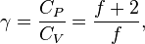  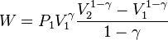 | C_{V} ln (T₂ / T₁) + R ln (V₂ / V₁)

Q = nC_{V}ΔT volume constant
Q = nC_{P}ΔT pressure constant
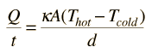 conduction 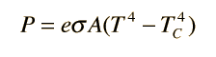 radiation
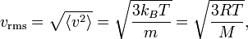

First law of thermodynamics
W_{out} = Q_{in} - Q_{out}

Second law of thermodynamics
e = W_{out} / Q_{in} <= e_{carnot} = 1 – T_{c}/T_{h} = 1 – Q_{c}/Q_{h}

Boltzmann distribution
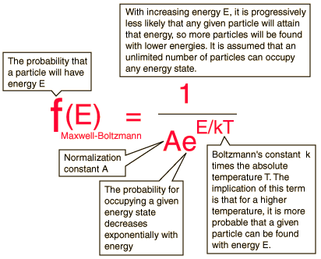

Gauss’s law
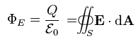
Gaussian Surface
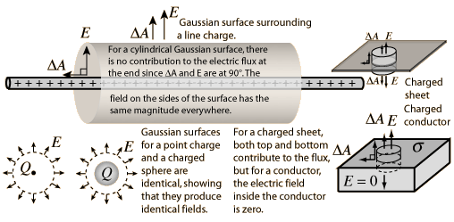

Line of charge
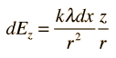
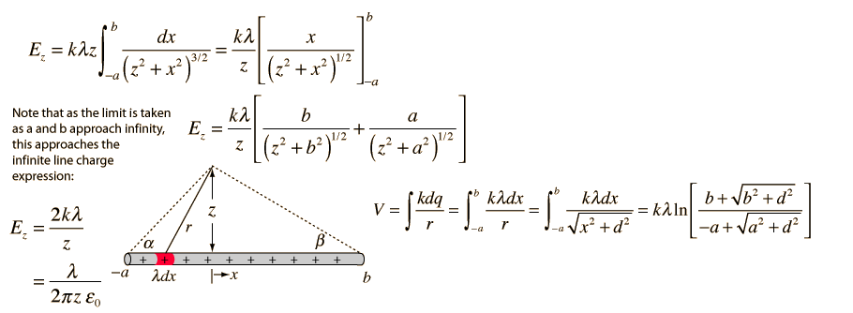

Charged disk
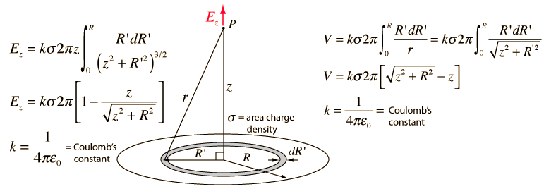
Ring of charge
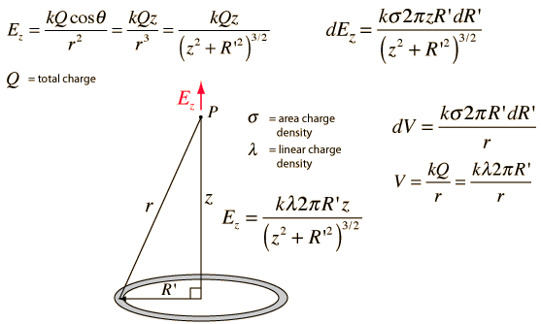

Circuits
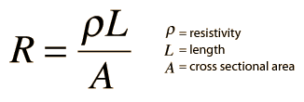 Electrical conductivity = σ = 1/ρ
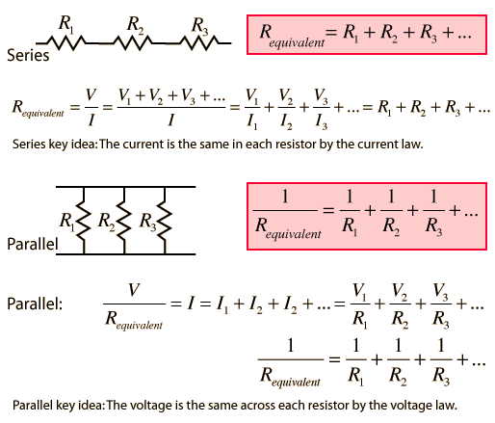

Kirchoff’s rule
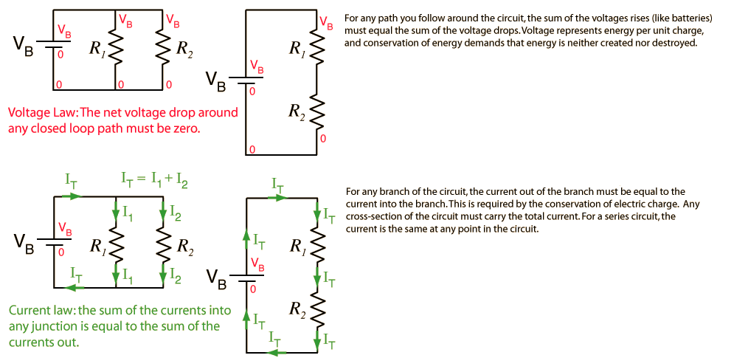

Capacitors
Parallel plate
Spherical | 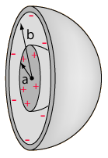 | 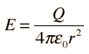  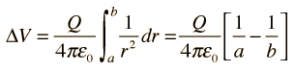  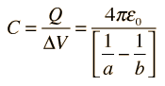
Cylindrical | 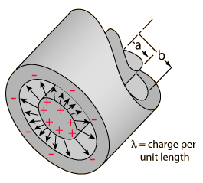 | 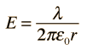  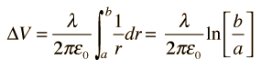  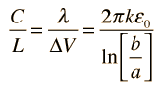

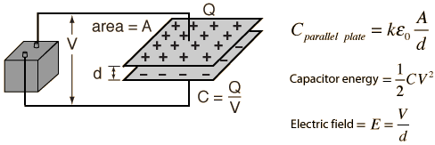

Dielectrics
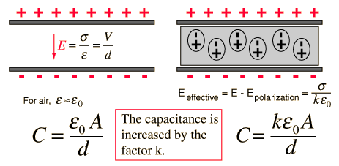

RC circuits

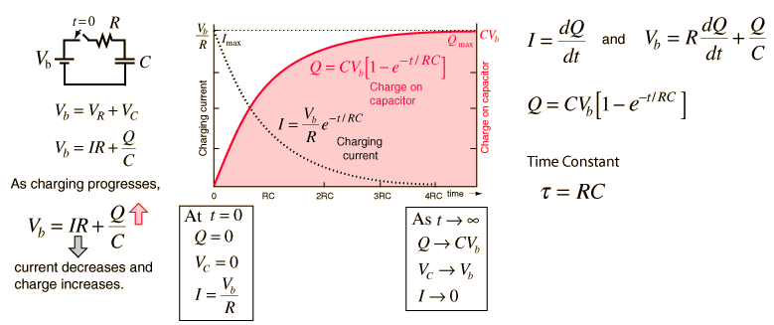

Lorentz force
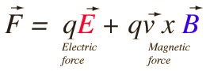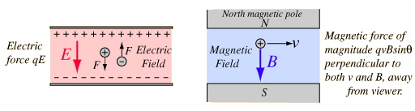

Ampere’s law
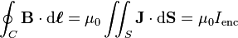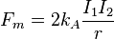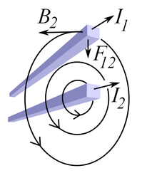
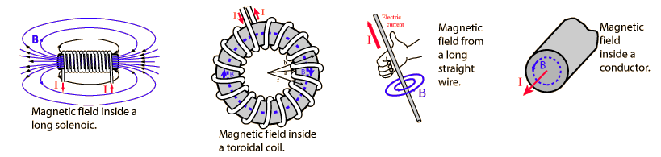

Biot-Savart Law
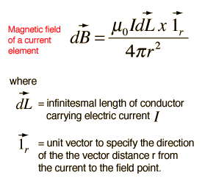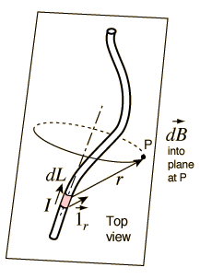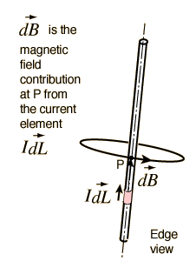
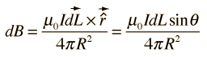
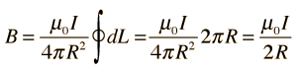
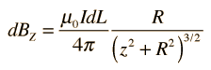
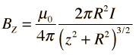
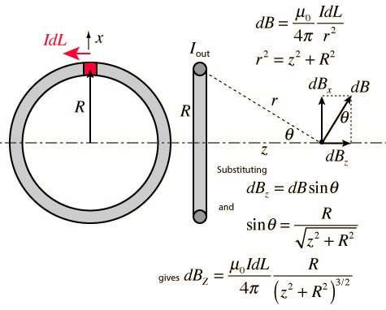

Lenz’s law
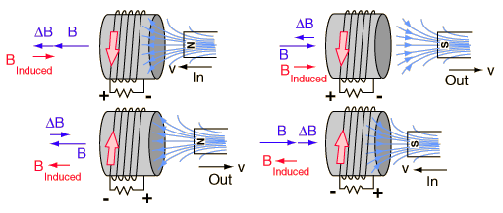
Faraday’s law
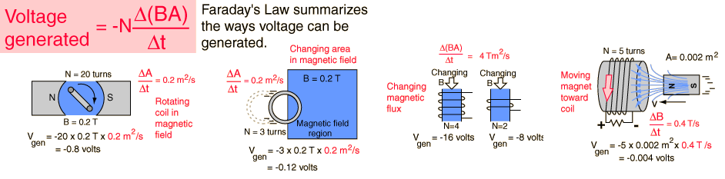

Motional EMF
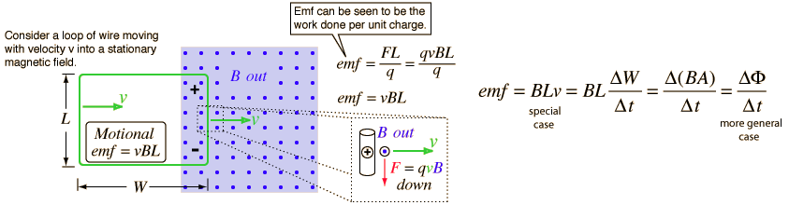

Inductance
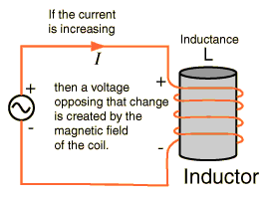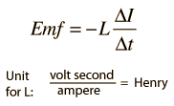

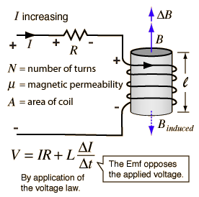 | 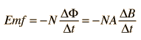  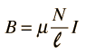  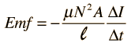  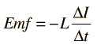  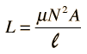
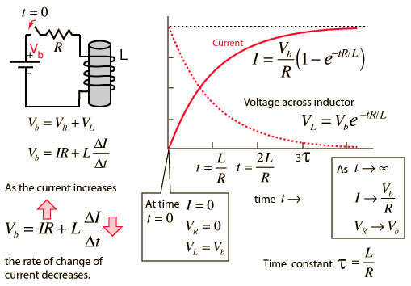

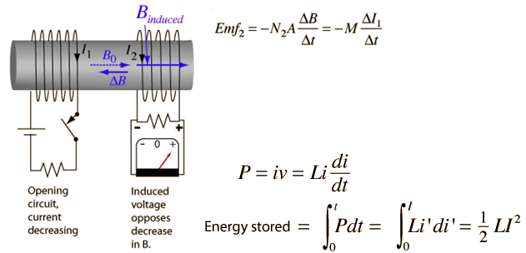
.
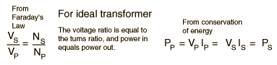
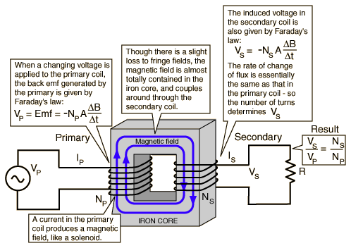
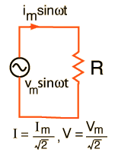

LC circuits
