Engineering stress, $σ=\frac{P(load)}{A_{0}}$ Engineering strain, $ϵ=\frac{l-l_{0}}{l_{0}}=\frac{∆l}{l_{0}}$
True stress = $\frac{P\left(load\right)}{Ai}$ where Ai is the area at the instant when the load is applied.
The two are different in the way the test data is reported. Engineering stress is always lower than true stress.
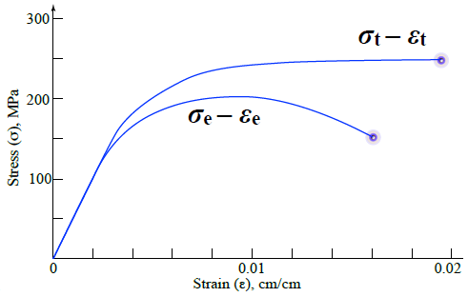 |  |  | The engineering stress curve exhibits an inflection point when the cross-sectional area of the sample begins to decease (“necking”), which is not taken into account in the definition of engineering stress, which assumes a constant (original) area. There can be no inflection point in the true stress because each increment of area reduction is included in the definition.  Both true stress and true strain add incrementally as deformation proceeds.
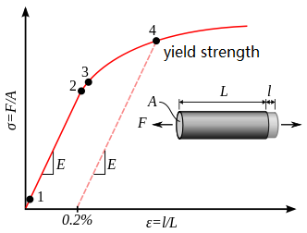 |  |  | Elastic deformation- temporary deformation that will be fully recovered when the load is removed; the linear region in the stress-strain curve.  Plastic deformation- permanent deformation that won’t be recovered when the load is removed; the non-linear region in the stress-strain curve.  Young’s modulus is the slope of the stress-strain curve.  A lower elastic modulus means that the sample is less elastic/ductile, and more brittle (softer). With the same bond energy, the more brittle sample would have more closely packed particles and lie further left on the bone energy curve.
Uniaxial tensile test  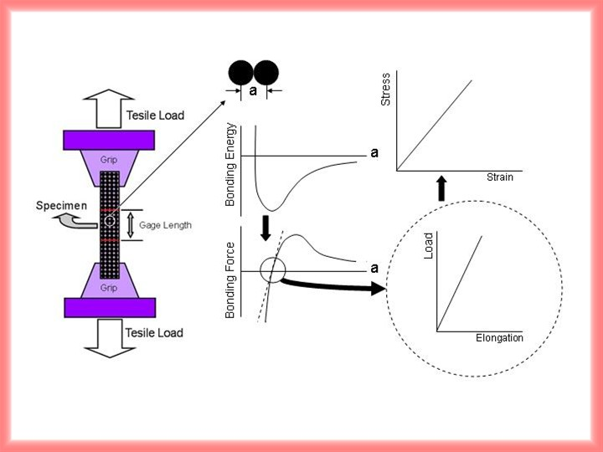 |  |  | Gage length- smallest area region  In order to convert the data from a load vs. elongation plot to a stress vs. strain plot, the geometry of the sample is essential.  Cyclic loading at low stress can cause failure by fatigue. The requirement of constant crosshead speed is achieved by reducing the load as necking begins, which influences the appearance of the stress-strain curve. It is the reason for the inflection point. It enables an identification of the onset of necking and the definition of the ultimate tensile strength.
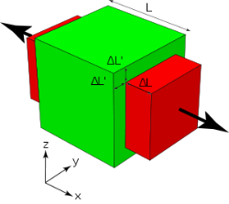 Poisson’s ratio: 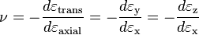
It describes: tension-induce contraction, and compression-induced expansion.
Stress-strain curve |  |  | Yield stress is found by 0.2% offset.  Dislocations are associated with plastic deformation, so they can only nucleate and glide at stress values greater than the yield stress (at yield point, elastic to plastic)  Within the stress-strain curve between Y.S. and T.S., the phenomenon of increasing strength with increasing deformation is strain hardening.  Necking occurs when the stress is at its maximum (tensile strength)  Ductility is the percent elongation at failure/fracture  Toughness – the combination of properties; the total area under the stress-strain curve. The ability of a material to absorb energy under load, measured in energy per volume.
Shear stress $τ=\frac{P_{s}}{A_{s}}$, where P_{s} is the load on the sample; A_{s} is the area of the sample parallel to the applied load.
$γ=\tan{a}$ shear modulus $G =\frac{τ}{γ}$
$$E=2G\left(1+v\right)$$
Hardness is resistance to penetration.
Test |  | Indenter |  | Load | Hardness number
Rockwell A |  | Diamond cone, leaving a hole of thickness t |  | 60 kg | $$100-500t$$
Brinelle |  | 10-mm sphere of steel or tungsten carbide |  | P | $$\frac{2P}{πD[D-\sqrt{D^{2}-d^{2}}}$$
Ductile-to-brittle transition is exhibited by most steels. At a critical temperature, known as the ductile-to-brittle transition temperature (DBTT), the amount of stress that causes catastrophic failure plunges, sometimes precipitously, to dangerously low levels, at times lower than the yield point recorded under higher temperature (above DBTT) conditions. This type of brittle failure is prominently linked to “impact” loading, where the load is applied at high strain rates, as effected in the Charpy test by a swinging hammer. The notched sample concentrates stress at the notch, ensuring that failure will occur there, allowing a measurement to be made of the “impact energy” absorbed by the sample. Nonferrous alloys do not exhibit a ductile-to-brittle transition.
Coulombic attraction, $F_{C}=-\frac{k_{0}\left(Z_{1}q\right)\left(Z_{2}q\right)}{a^{2}} where k_{0}=9*{10}^{9}\frac{V m}{C}$ $F_{R}=x e^{-\frac{a}{p}} x and p are experimental values$
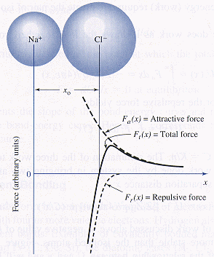 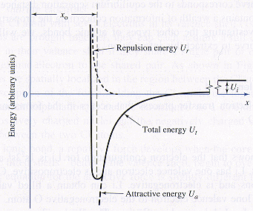 $F=\frac{dE}{da}$
Primary bonds- formed been individual atoms or ions, chemical bonds
Secondary bonds- formed between groups of atoms after primary bonding has occurred, more likely to be physical. Long chain polymers: covalent bonds within chains and secondary bonds among chains.
Carbon atoms in graphite are covalently bonded within planar layers but have weaker secondary bonds between layers, which makes graphite powder acts so well as a solid lubricant.
Coordination number (CN) is the number of adjacent ions/ atoms surrounding a reference ion/atom.
Metallic alloys have higher coordination numbers than materials that form ionic bonds.
Possible CNs: 2, 3, 4, 6, 8, 12 (maximum closest packing)
Van der Waals causes molecular bonding by induced electric dipoles.
Two water molecules are “bonded” due to a functional hydrogen bridge (dipole bonding).
Metallic bonding model explains ductility on the basis of lack of bond directionality. Metals have the opportunity for extended orbital overlap of bonding electrons during deformation. These concepts explain elastic behavior, characterized by fully recoverable strain, as the stretching of atomic bonds, and plastic behavior, characterized by a non-recoverable strain resulting in permanent deformation as the breaking and restoration (at different sites) of atomic bonds (the dislocation mechanism of plastic deformation). Non-directionality of orbital overlap enables an extended range of plastic deformation). Non-directionality of orbital overlap enables extended range of plasticity in most metallic alloys.
The observed differences in Poisson’s ratio between two “metallically bonded” solids suggest that some directionality may be at play. Under these circumstances, there is an intrusion of some “covalent character” to the bonds, as also used to rationalize the CN=8 in BCC metals.

Covalent bonding occurs by a special type of electron sharing most often described as overlapping of valence electron orbitals. Where overlap occurs, electron density is increased, enhancing bond strength and inducing a corresponding directionality in covalent bonding. The directions along which orbital overlap is greatest are those that form the strongest bonds. The direction is established by the tendency of covalently bonded atoms to maximize the amount of orbital overlap. In semiconductors, the amount of orbital overlap is increased by sp3 hybridization, causing the tetrahedral coordination (CN=4) found in GaAs.
Ionic bonding is not directional. What induces the structure exhibited by CsCl with its coordination number CN = 8 is simply space filling, the packing of small cations and large anions to preserve charge neutrality at highest density. At specific ratios of ionic radii the coordination numbers of ionic solids change. Directionally bonded solids like GaAs and pure Si have a fixed CN = 4 even as their atomic radius ratios vary. The structure of CsCl is therefore considered a consequence of packing geometry, not bond directionality. During charge transfer, cations decrease in size, and anions increase in size, imposing a size effect on how they can pack together in solid state. This packing geometry is limited by the radius ratio, and the resulting CN, influencing the development of crystal structure in ionic solids.

The motion of valence electrons under an applied electrical voltage is the reason for its electrical conductivity, but not all bonding electrons are moved in such currents. The electron distribution in Cu wiring continues to secure the bond strengths of the Cu atoms because the circuit continuously resupplies electrons from a source as they flow through the conductors comprising the circuit towards a drain. In the absence of a closed circuit, high fields can indeed extract electrons from the Cu, breaking bonds, and resulting in structural damage.

Van der Waals bond form in polyethylene (covalently bonded C and H in the chain configuration sown above) by the dipolar attraction between adjacent chains or coiled/folded segments of the same chain. The positively charged portions of the chain populated by hydrogen and negatively charged portions of an adjacent chain between the hydrogen atoms are attracted to one another. The function of such a bond is to give strength to the structure, enough to sustain a solid phase but not strong enough to withstand even a small temperature rise, which causes severe softening of the structure, and a relatively low meting temperature.

Facts about steel
- Crystalline as a consequence of metallic bonding
- Alloy of Fe and C, but iron doesn’t form molecules with C, no secondary bonding, only primary bonding
- Bravais lattice with Fe atoms on lattice sites and C atoms located interstitially between lattice sites
- Cementite is not a molecule, but one of the solid phases found in steel
- Micro constituent phases of steel are products of primary bonds, sometimes purely metallic and sometimes mixed metallic and covalent character.
- The hardness and malleability of steel depends not only on the carbon content, but also prior austenite grain size, amount and distribution of microconstituent phases, and dislocation content.
Lattice- an array of points in space (a mathematical construction) with identical environment
Motif- assignment of atoms or ions to each and every lattice point in exactly the same way
The 7 lattice systems | The 14 Bravais lattices
Triclinic | P
 | 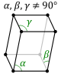
Monoclinic | P | C
 | 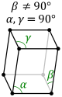 | 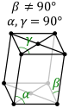
Orthorhombic | P | C | I | F
 | 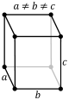 | 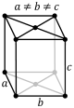 | 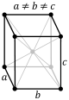 | 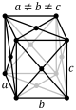
Tetragonal | P | I
 | 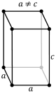 | 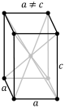
Rhombohedral | P
 | 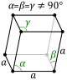
Hexagonal | P
 | 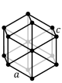
Cubic | P (pcc) | I (bcc) | F (fcc)
 | 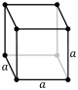 | 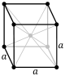 | 