Chemical Engineering 141 2nd Midterm
H = U + PV
A = U – TS
G = H – TS

dU = TdS – PdV ${(\frac{∂T}{∂U})}_{S}=-{(\frac{∂P}{∂S})}_{V}$
dH = TdS + VdP ${(\frac{∂T}{∂P})}_{S}={(\frac{∂V}{∂S})}_{P}$
dA = -PdV – SdT ${(\frac{∂P}{∂T})}_{V}={(\frac{∂S}{∂V})}_{T}$
dG = VdP – SdT ${(\frac{∂V}{∂T})}_{P}=-{(\frac{∂S}{∂P})}_{T}$

Enthalpy as a function of T and P $dH=C_{P}dT+\left[V-T{\left(\frac{∂V}{∂T}\right)}_{P}\right]dP dH=C_{P}dT+\left(1-βV\right)VdP$
Entropy as a function of T and P $dS=C_{P}\frac{dT}{T}-{\left(\frac{∂V}{∂T}\right)}_{P}dP$ $dS=C_{P}\frac{dT}{T}-βVdP$
Internal Energy as a function of P ${(\frac{∂U}{∂P})}_{T}=-T{\left(\frac{∂V}{∂T}\right)}_{P}-P{\left(\frac{∂V}{∂P}\right)}_{T}$
Ideal gas ${dH}^{ig}={C_{P}}^{ig}dT {dS}^{ig}={C_{P}}^{ig}\frac{dT}{T}-R\frac{dP}{P}$
Alternative forms for liquids ${(\frac{∂S}{∂P})}_{T}=-βV {\left(\frac{∂H}{∂P}\right)}_{T}=\left(1-βT\right)V$

Internal Energy as function of T and V
$${\left(\frac{∂S}{∂T}\right)}_{V}=\frac{C_{V}}{T} {\left(\frac{∂U}{∂V}\right)}_{T}=T{\left(\frac{∂P}{∂T}\right)}_{V}-P$$
$$dU=C_{V}dT+\left[T{\left(\frac{∂P}{∂T}\right)}_{V}-T\right]dV dU=C_{V}dT+\left[T\frac{β}{K} -P\right]dV$$
$$dS=C_{V}\frac{dT}{T}+{\left(\frac{∂P}{∂T}\right)}_{V}dV dS= \frac{C_{V}}{T}dT+\frac{β}{K}dV$$

The Gibbs Energy as a Generating Function
$$dG=VdP-SdT$$
$$d\left(\frac{G}{RT}\right)=\frac{1}{RT}dG-\frac{G}{RT^{2}}dT=\frac{V}{RT}dP-\frac{H}{RT^{2}}dT$$
$$\frac{V}{RT}={[\frac{∂(\frac{G}{RT})}{∂P}]}_{T} \frac{H}{RT}=-T{[\frac{∂\left(\frac{G}{RT}\right)}{∂T}]}_{P}$$

Residual properties
M^{R} = M-M^{ig}
$$\frac{S^{R}}{R}= -T \int_{0}^{P}{{\left(\frac{∂Z}{∂T}\right)}_{P}}\frac{dP}{P}- \int_{0}^{P}{\left(Z-1\right)}\frac{dP}{P}$$
$$\frac{G^{R}}{RT}= \int_{0}^{P}{\left(Z-1\right)}\frac{dP}{P}$$

 | Virial EOS | Cubic EOS
$$\frac{G^{R}}{RT}$$ | $$\int_{0}^{ρ}{\left(Z-1\right)\frac{dρ}{ρ}}+Z-1-\ln{Z}$$ | $$Z-1-\ln\left(Z-β\right)-qI$$
$$\frac{H^{R}}{RT}$$ | $$-T\int_{0}^{ρ}{{(\frac{∂Z}{∂T})}_{ρ}\frac{dρ}{ρ}}+Z-1$$ | $$Z-1+[\frac{d\ln{α(T_{r}})}{d\ln{T_{r}}}-1]-qI$$
$$\frac{S^{R}}{R}$$ | $$\ln{Z}-T\int_{0}^{ρ}{{(\frac{∂Z}{∂T})}_{ρ}\frac{dρ}{ρ}}-\int_{0}^{ρ}{(Z-1)\frac{dρ}{ρ}}$$ | $$\ln{(Z-β)}+[\frac{d\ln{α(T_{r}})}{d\ln{T_{r}}}]-qI$$
$$I=\int_{0}^{ρ}{\frac{d\left(ρb\right)}{(1+ϵρb)(1+σρb)}}$$
Two Phase Systems
$$\ln{P^{sat}}=A-\frac{B}{T+C} \ln{{P_{r}}^{sat}}=\frac{Aτ+Bτ^{1.5}+Cτ^{3}+Dτ^{6}}{1-τ} τ=1-T_{r}$$
Liquid/Vapor Systems
$$M=\left(1-x^{v}\right)M^{l}+x^{v}M^{v}=M^{l}+x^{v}∆M^{lv} M represents V, U, H, S$$
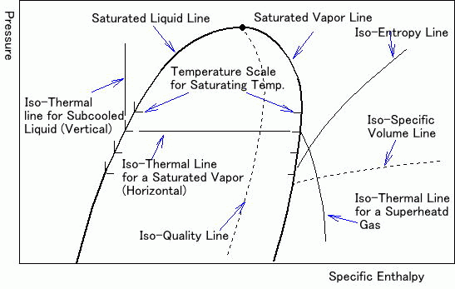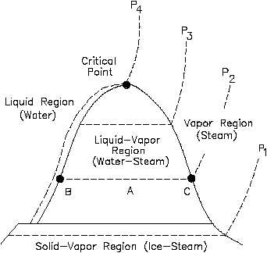
Generalized property correlations for gases
$$\frac{H^{R}}{RT_{c}}=\frac{{{(H}^{R})}^{0}}{RT_{c}}+ω\frac{{{(H}^{R})}^{1}}{RT_{c}} \frac{S^{R}}{R}=\frac{{{(S}^{R})}^{0}}{R}+ω\frac{{{(S}^{R})}^{1}}{R}$$
$$∆H={C_{P}^{ig}}_{H}\left(T_{2}-T_{1}\right)+H_{2}^{R}-H_{1}^{R}$$
$$∆S={C_{P}^{ig}}_{S}\ln{\frac{T_{2}}{T_{1}}}-R\ln{\frac{P_{2}}{P_{1}}}+S_{2}^{R}-S_{1}^{R}$$
Equations of Balance
General equations | Steady-flow | Single-stream steady-flow
$$\frac{{dm}_{CV}}{dt}+∆{(\dot{m})}_{fs}=0$$ | $$∆{(\dot{m})}_{fs}=0$$ | $${\dot{m}}_{1}={\dot{m}}_{2}={\dot{m}}_{3}$$
$$\frac{{d(mU)}_{CV}}{dt}+∆{[(H+\frac{1}{2}u^{2}+zg)\dot{m}]}_{fs}=\dot{Q}+\dot{W}$$ | $$∆{[(H+\frac{1}{2}u^{2}+zg)\dot{m}]}_{fs}=\dot{Q}+\dot{W}$$ | $$∆H+\frac{{∆u}^{2}}{2}+∆zg=\dot{Q}+\dot{W}$$
$$\frac{{d(mS)}_{CV}}{dt}+∆{(S\dot{m})}_{fs}-\sum{\frac{{\dot{Q}}_{j}}{T_{σ,j}}=\dot{S_{G}}≥0}$$ | $$∆{(S\dot{m})}_{fs}-\sum{\begin{aligned}\frac{{\dot{Q}}_{j}}{T_{σ,j}} \\ =\dot{S_{G}}≥0\end{aligned}}$$ | $$∆S-\sum{\frac{Q_{j}}{T_{σ,j}}=\dot{S_{G}≥0}}$$
Throttling process
$$∆H=H_{2}-H_{1}=0$$
Joule/Thomson coefficient
$$μ={(\frac{∂T}{∂P})}_{H}=\frac{RT^{2}}{C_{P}P}{(\frac{∂Z}{∂T})}_{P} { ( \frac{∂H}{∂P} )}_{T}=V-T{(\frac{∂V}{∂T})}_{P}$$
Turbines (expanders)
$$\dot{W_{s}}=\dot{m}∆H=\dot{m}\left(H_{2}-H_{1}\right) W_{s}=∆H=H_{2}-H_{1}$$
$$η=\frac{W_{s}}{W_{s}(isentropic)}=\frac{∆H}{{(∆H)}_{S}}$$
Compression processes
$$η=\frac{W_{s}(isentropic)}{W}=\frac{{\left(∆H\right)}_{S}}{∆H}$$
$$W_{s}\left(isentropic\right)=C_{P}T_{1}\left[{\left(\frac{P_{2}}{P_{1}}\right)}^{\frac{R}{C_{P}}}-1\right]$$
$$T_{2}=T_{1}+\frac{∆H}{{C_{P}}_{H}}=T_{1}+\frac{T_{1}\left[{\left(\frac{P_{2}}{P_{1}}\right)}^{\frac{R}{C_{P}}}-1\right]}{η}$$
Pumps
$$dH=C_{P}dT+V\left(1-βT\right)dP ∆H=C_{P}∆T+\left(1-βT\right)∆P$$
$$dS=C_{P}\frac{dT}{T}-βVdP ∆S=C_{P}\frac{T_{2}}{T_{1}}-βV∆P$$

Rankine Cycle
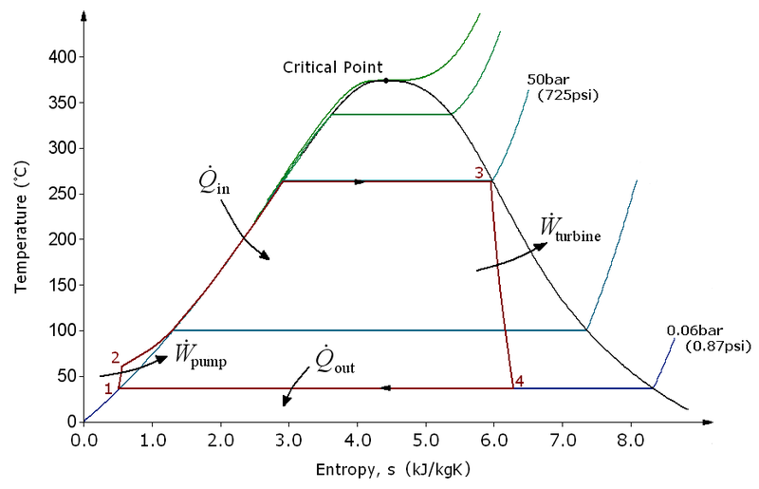 | 1-2: reversible, adiabatic (isentropic) pumping of the saturated liquid to the pressure of the boiler, producing compressed (subcooled) liquid. $∆T is small$  2-3: heating of subcooled liquid water to its saturation temperature, vaporization at constant temperature and pressure, and superheating of the vapor to a temperature well above its saturation temperature  3-4: reversible, adiabatic (isentropic) expansion of vapor in a turbine to the pressure of the condenser.  4-1: constant-pressure, constant temperature process in a condenser to product saturated liquid
$$Q=∆H \dot{Q}=\dot{m}∆H$$
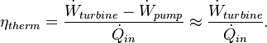
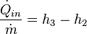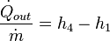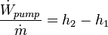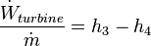

Otto cycle
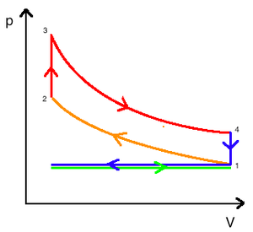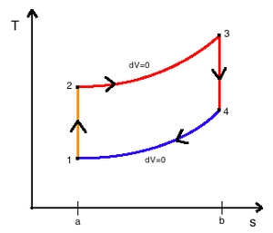 | - intake stroke  A mass of air (working fluid) is drawn into the cylinder, from 0 to 1, at atmospheric pressure (constant pressure) through the open intake valve  1-2 compression stroke  Isentropic compression, compression ratio V₁/V₂  2-3 ignition  Isochoric, heat is added, pressure rises, temperature increases, pressure ratio P₃/P₂  3-4 expansion stroke  Fluid expands isentropically, expansion ratio, V₄/V₃  4-1 heat ejection  Isochoric, heat is removed, pressure drops, temperature decreases  $$Q_{23}=C_{V}\left(T_{3}-T_{2}\right) Q_{41}=C_{V}\left(T_{1}-T_{4}\right)$$  $$η=\frac{\left|W_{net}\right|}{Q_{23}}=\frac{{Q_{23}+Q}_{41}}{Q_{23}}=\frac{C_{V}\left(T_{3}-T_{2}\right)+C_{V}\left(T_{1}-T_{4}\right)}{C_{V}\left(T_{3}-T_{2}\right)}$$  $$η=1-\frac{\left(T_{4}-T_{1}\right)}{\left(T_{3}-T_{2}\right)}=1-\frac{V_{1}}{V_{2}}\frac{\left(P_{4}-P_{1}\right)}{\left(P_{3}-P_{2}\right)}=1-r\frac{\left(P_{4}-P_{1}\right)}{\left(P_{3}-P_{2}\right)}$$  $$η=1-r{\left(\frac{1}{r}\right)}^{γ}=1-{\left(\frac{1}{r}\right)}^{γ-1}$$

Diesel cycle
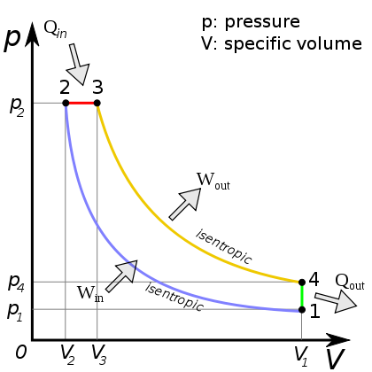 | $$Q_{23}=C_{P}\left(T_{3}-T_{2}\right) Q_{41}=C_{V}\left(T_{1}-T_{4}\right)$$  $$η=1+\frac{Q_{41}}{Q_{23}}=1+\frac{C_{V}\left(T_{1}-T_{4}\right)}{C_{P}\left(T_{3}-T_{2}\right)}=1-\frac{1}{γ}\frac{\left(T_{4}-T_{1}\right)}{\left(T_{3}-T_{2}\right)}$$  $$r=\frac{V_{1}}{V_{2}} r_{e}=\frac{V_{4}}{V_{3}}$$  $$η=1-\frac{1}{γ}\left[\frac{{T_{3}{\left(\frac{1}{r_{e}}\right)}^{γ-1}-T}_{3}{\left(\frac{1}{r}\right)}^{γ-1}}{T_{3}-T_{2}}\right]=1-\frac{1}{γ}\left[\frac{{\left(\frac{1}{r_{e}}\right)}^{γ}-{\left(\frac{1}{r}\right)}^{γ}}{\left(\frac{1}{r_{e}}\right)-\left(\frac{1}{r}\right)}\right]$$  1-2 isentropic compression  2-3 isobaric expansion  3-4 isentropic expansion  4-1 isochoric cooling

Brayton Cycle / Gas Turbine Engine
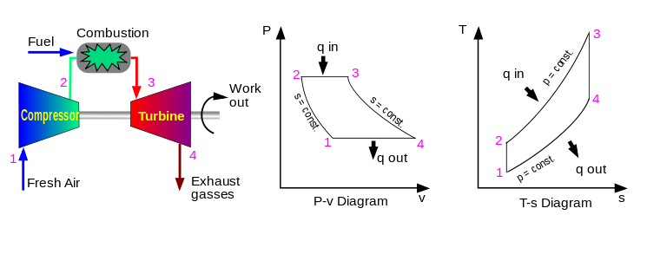
$$Q_{23}=C_{P}\left(T_{3}-T_{2}\right) {|W}_{34}|=C_{P}\left(T_{3}-T_{4}\right) \frac{T_{2}}{T_{1}}={\left(\frac{P_{2}}{P_{1}}\right)}^{\frac{γ-1}{γ} } \frac{T_{4}}{T_{3}}={\left(\frac{P_{4}}{P_{3}}\right)}^{\frac{γ-1}{γ} }={\left(\frac{P_{1}}{P_{2}}\right)}^{\frac{γ-1}{γ} }$$
$$η=\frac{\left|W_{net}\right|}{Q_{23}}=\frac{{\left|W_{34}\right|-W}_{12}}{Q_{23}}=1-\frac{T_{4}-T_{1}}{T_{3}-T_{2}}=1-{\left(\frac{P_{1}}{P_{2}}\right)}^{\frac{γ-1}{γ} }$$
1-2 isentropic compression
2-3 isobaric expansion/heating
3-4 isentropic expansion/cooling
4-1 isobaric compression

Refrigeration
$$W=\left|Q_{H}\right|-\left|Q_{C}\right|$$
$$ω=\frac{\left|Q_{C}\right|}{W}=\frac{T_{C}}{T_{H}-T_{C}}$$
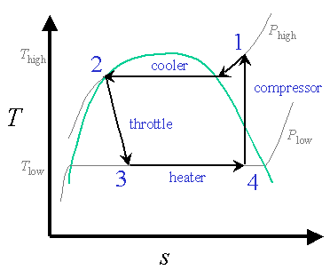 |  | 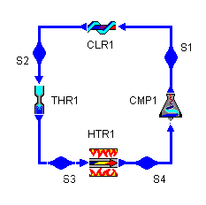  $$ω=\frac{H_{4}-H_{3}}{H_{1}-H_{4}}$$
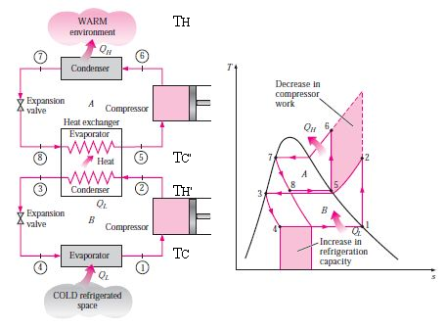  $$\frac{1}{ω_{cascade}}=\frac{1}{ω_{1}}+\frac{1}{ω_{2}}=\frac{{T_{H}}^{'}-T_{C}}{T_{C}}\frac{T_{H}-T_{C}'}{T_{H}}$$ |  | 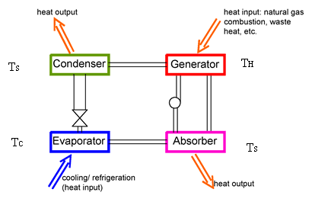  $$W=\frac{{T_{S}-T}_{C}}{T_{C}}\left|Q_{C}\right|$$  $$\left|Q_{H}\right|=\left|Q_{C}\right|\frac{T_{H}}{T_{H}-T_{S}}\frac{T_{S}-T_{C}}{T_{C}}$$
Claude liquefaction process  $$z=\frac{H_{2}{-H}_{1}}{{H_{f}-H}_{1}}$$ | 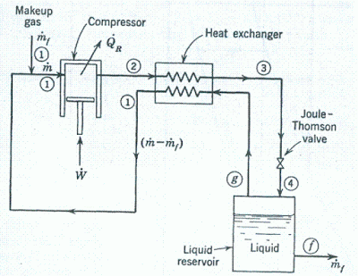  Linde liquefaction process  $$z=\frac{H_{2}{-H}_{1}}{{H_{f}-H}_{1}}$$

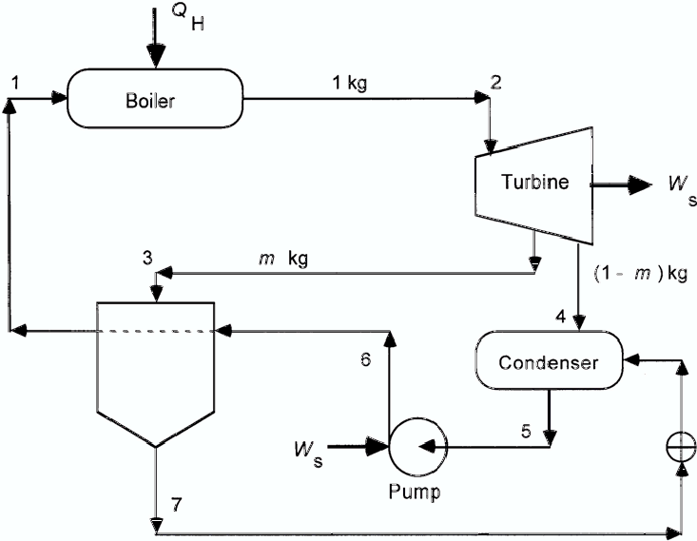  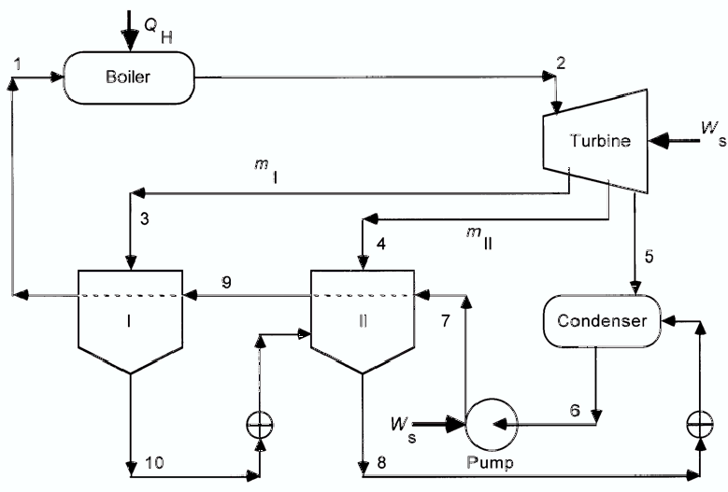 | $$W_{pump}=\frac{V_{5}\left(P_{6}-P_{5}\right)}{η} H_{6}=H_{5}+W_{pump}$$  $$mass=\frac{H_{1}-H_{6}}{H_{3}-H_{7}}$$  $$H_{1}=H_{sat,liq}+V_{sat,liq}\left(1-βT_{1}\right)(P_{1}-P_{sat})$$  $$W_{I}=η\left(H_{3}^{'}-H_{2}\right) H_{3}^{'} at S_{2} and P_{3}$$  $$W_{net}={(W}_{I}+W_{pump})*1+\left(1-m\right)\left(H_{4}-H_{3}\right)$$  $$Q_{H}=H_{2}-H_{1}$$  $$η=\frac{\left|W_{net}\right|}{Q_{H}}$$  $$m_{I}=\frac{H_{1}-H_{9}}{H_{3}-H_{10}}$$  $$m_{II}=\frac{\left(H_{9}-H_{7}\right)*1kg-\left(1-m_{I}\right)\left(H_{10}-H_{8}\right)}{H_{4}-H_{8}}$$  $$W_{pump}=\frac{V_{6}\left(P_{2}-P_{6}\right)}{η}$$  $$W_{I}=η\left(H_{3}^{'}-H_{2}\right) H_{3}^{'} at S_{2} and P_{3}$$  $$W_{turbine}=W_{I}*1 kg+\left(1-m_{I}\right)\left(H_{4}-H_{3}\right)+\left(1-m_{I}-m_{II}\right)\left(H_{5}-H_{4}\right)$$  $$Q_{H}=H_{2}-H_{1}$$  $$η=\frac{\left|W_{turbine}+W_{pump}*1kg\right|}{Q_{H}}$$

Phase Rule: $F=2-π+N$
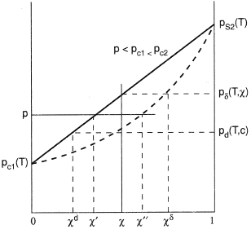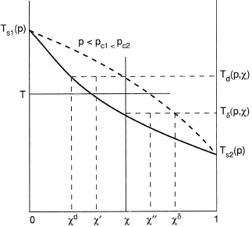
P-x diagram T-x digram

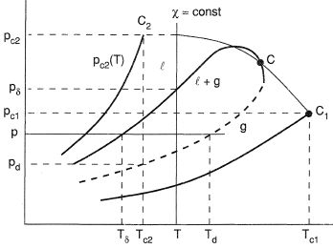 PT diagram
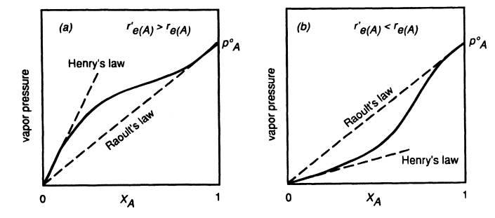
$$y_{i}P=x_{i}P_{i}^{sat}$$  $$P=\sum_{i}{x_{i}}P_{i}^{sat}=\frac{1}{\sum_{i}{y_{i}/P_{i}^{sat}}}$$  Modified Raoult’s law  $$y_{i}P=x_{i}{γ_{i}P}_{i}^{sat}$$  $$P=\sum_{i}{x_{i}{γ_{i}P}_{i}^{sat}=\frac{1}{\sum_{i}{y_{i}/γ_{i}P_{i}^{sat}}}}$$  y is vapor phase  x is liquid phase  $$\sum_{i}{y_{i}}=\sum_{i}{x_{i}}=1$$  $$K_{i}=\frac{y_{i}}{x_{i}} \sum_{i}{{K_{i}x}_{i}=}\sum_{i}{\frac{y_{i}}{K_{i}}=}1$$ | $$y_{i}P=x_{i}H_{i}$$

Antoine equation $\ln{P_{i}^{sat}=A-\frac{B}{T+C}}$
Bubble point {x_{i}}, T, given  - get {P_{i}^{sat}}$\ln{P_{i}^{sat}=A-\frac{B}{T+C}}$ by T  - $P=x_{1}P_{1}^{sat}+\left(1-x_{1}\right)P_{2}^{sat}$  - $y_{1}=\frac{x_{1}P_{1}^{sat}}{P} y_{2}=\frac{\left(1-x_{1}\right)P_{2}^{sat}}{P} y_{2}=1-y_{1}$ | Dew point {y_{i}}, T, given  - get {P_{i}^{sat}}$\ln{P_{i}^{sat}=A-\frac{B}{T+C}}$ by T  - $P=\frac{1}{\frac{y_{1}}{P_{1}^{sat}}+\frac{\left(1-y_{1}\right)}{P_{2}^{sat}}}$  - $x_{1}=\frac{y_{1}P}{P_{1}^{sat}} x_{2}=\frac{\left(1-y_{1}\right)P}{P_{2}^{sat}} x_{2}=1-x_{1}$
Bubble point {x_{i}}, P, given  - Plug P into Antoine equation as the P_{i}^{sat} to calculate T_{i}^{sat}. As an initial guess  $$T=x_{1}T_{1}^{sat}+\left(1-x_{1}\right)T_{2}^{sat}$$  - Calculate {P_{i}^{sat}} at this T.  - Choose one species k as a reference:  $choose 1: P_{1}^{sat}=\frac{P}{x_{1}+\left(1-x_{1}\right)\frac{P_{2}^{sat}}{P_{1}^{sat}}}$ $choose 2: P_{2}^{sat}=\frac{P}{x_{2}+\left(1-x_{2}\right)\frac{P_{1}^{sat}}{P_{2}^{sat}}}$  - Plug in P₁^{sat} or P₂^{sat} in Antoine equation to get a new value for T.  - Go back to step 2 until T converges. | Dew point {y_{i}}, P, given  - Plug P into Antoine equation as the P_{i}^{sat} to calculate T_{i}^{sat}. As an initial guess  $$T=y_{1}T_{1}^{sat}+\left(1-y_{1}\right)T_{2}^{sat}$$  - Calculate {P_{i}^{sat}} at this T.  - Choose one species k as a reference:  $choose 1: P_{1}^{sat}=P(y_{1}+\left(1-y_{1}\right)\frac{P_{1}^{sat}}{P_{2}^{sat}}$) $choose 2: P_{2}^{sat}=P(y_{2}+\left(1-y_{2}\right)\frac{P_{2}^{sat}}{P_{1}^{sat}}$)  - Plug in P₁^{sat} or P₂^{sat} in Antoine equation to get a new value for T.  - Go back to step 2 until T converges.

