Leadership ethics
Values
- Diversity
- Spirituality
- Social media and leadership
- Culture
- Mindfulness
The problem
- Structure
- Stress of Leadership
- Vision of one’s Self
- Allowing others to fail
- Accepting best efforts over perfection
The solution
- Lead as others see you
  - openness – Chambers
  - honest feedback-Ellison
- Hope
  - Contagious Strategy
  - Effect change
  - Realistic
- Compassion
Execution
- Intellectually curious
- Caring about people
- Universality of family
- Integration of capabilities BPO
- Collaboration
- Common Vision
- The idea is greater than the parts
- Co-leaders
- Incentives based upon implementing values
The Results
- Revenues grow
- Turnover decreases
- Brand improves
- Better customer experience
Moral intuitions
- Gut reactions
- Past experiences
- The need for ethics
What is ethics?
  - “Theory of Living” from the Greeks
  - Ethical deliberation
  - Conscious reasoning right & wrong
  - Not always black & white
  - Morally defensible
Disagreements in ethics
  - Facts
  - Values & principles
  - Language
  - Framing
  - Important to understand agreements
  - Constructive solution
  - Agreement with facts
  - Self-preservation or Company loyalty
Levels of inquiry
- Society
- Corporations and Corporate Policies
- Stakeholders
- Personal
Ethical frameworks
- Methodology
- A set of questions: Drive to a resolution
- Ethical traditions:
    - Character
    - Consequences
    - Principles
Putting it to practice
  - Can I make a difference?
  - Accountability of managers
  - Ethical problems are part of the job
  - Personal integrity
  - Legal reasoning
  - Integration thesis
Employee
  - Has job description
  - Works as team member
  - Can predict workload
  - Committed to helping company succeed
  - Loyal to a process
  - Wants to be promoted, see earnings increase
  - Enjoys operating in structured environment
  - Risk adverse
Entrepreneur
  - Visionary
  - Defines new markets and Pushes the envelope/thinks outside the box
  - Not necessarily focused on money or financial gain
  - Risk-taker
  - Leadership
  - Develops processes and inspires others to follow
  - A continuous learner
Indispensability Ethics & Leadership
- Human interaction
- The Difference between leaders &managers
- Opportunity
Culture is defined by the CEO
  - The CEO needs to be all in
  - This requires him to be vulnerable
  - Culture is dynamic it changes

Elements of a Corporate Culture
  - The working atmosphere
  - Communication is key
    - Transparency
    - Honesty
    - Authenticity
  - Employee engagement
Engagement
Elements of motivation
  - Awards and recognition
  - Compensation
  - Benefits
How to Build a Culture
  - Rock the rock
  - Stanford marching band
  - Executive servitude
Cultural - Sega Corporations & Policy
- Cultural - Sega
- Corporations & Policy
Fun at work
- Open arcade
- Games at work
- Employees first
Culture creates ethical frameworks
- Apple
- Harley Davidson
- The Rolling Stones9
Social media and timing influences ethics
- Public accounting
- Catholic church
- Merrill Lynch & other banks
- Government
Spiritual leadership
  - Mormon church
  - Bain Capital –Romney
  - Marriot hotels - Adult movies
  - Joel Olsen – Lakewood church
Ethical Frameworks
- Bottom 10%
- String out vendors
- Shareholders versus employees
- Changing titles in Asia
Mission statement
Tectura’s mission is to provide clients with innovative solutions and services of the highest quality and provide employees an environment of professional excellence for personal growth.
  - Ethics
  - Vision
  - Fun
Ways to measure culture
- Social Media
- Turnover
- Satisfaction Surveys
Ethical Leaders - Personal
- Lincoln
  - Preach a vision
  - Writ of habeas corpus
  - Emancipation proclamation
  - A Team of Rivals
- Churchill
- Paris Peace Talks

How to listen
- The most common reason for poor listening is poor time management
- Listening requires discipline.
- Set the scene for alternative listening
- Get to the meetings early, if only by a few minutes
- Be aware of how much talking you do compared to the other person
- Resolve not to let your mind wander
- Listening is only part of the listener’s role.
- Giving cues that are genuinely encouraging, even when there may be disagreement.
- When you’re aware of the subject of an interchange in advance, try to identify your biases and put them in abeyance..

Mindfulness, hope, and compassion
- When leaders face power stress over the long term and cannot find ways to manage its downside, they risk becoming trapped in the Sacrifice Syndrome, a vicious circle leading to mental and physical distress, and sometimes even executive burnout.
- Emotions are contagious; the dissonance they create will spread to those around them.
- Mindfulness starts with self-awareness knowing yourself enables you to make choices about how you respond to people and situations. Deep knowledge about yourself enables you to be consistent, to present yourself authentically. Mindfulness allows you to notice that subtle clues that tell you to attend carefully to self, others or your surroundings.
- Hope has a positive impact on our brains and hormones.
- The leader needs to have dreams and aspirations, but also to be in touch with the people who surround him. This helps to form a desired image of the future that can be shared.
- The leader needs to be optimistic and believe in his ability to effect change.
- The leader must see the desired future as realistic.
- Compassion
  - Understanding of and empathy for others feelings and experiences
  - Caring for others
  - Willingness to act on those feelings of care and empathy

Communications
- What is Communications?
“The sharing of information between two or more individuals or groups to reach a common understanding.”
  - Does not mean that people agree with each.
  - It means that must have a relatively accurate idea of what a person is trying to tell them.
  - It does not work if the people do not receive the information they need or the information is unclear.
Functions of communications
- Providing Knowledge
  - Goals, Job Performance, Standards, Needed, Changes
- Expressing Feelings
  - Emotions, Moods, Excitement, Anger
- Team Motivation
  - Improving Jobs, Setting
  - Expectancies, Goal Settings
- Controlling Activities
  - Defining Roles, Setting Rules and Norms
  - Communications Model- Process Components
    - Sender/Receiver
    - Message
Encoded/Decoded
    - Channel (medium)
      - Written
      - Verbally
      - Non-Verbally
      - Electronically
        - Email
- Sending the Message
  - Must be clear
    - Easily interpreted by the receiver
    - Easily understood by the receiver
  - Must be as complete as possible
    - All the information must be there
    - Withholding key information is a real problem
Sender is worried about the receipt
Sender is worried about his/her job
  - The sender must not be vague or unsure

Jargon
- Specialized Terminology
  - Not Understandable by all
  - Effective use of Jargon
    - When the group is homogeneous
      - Professionals – Physicians, Lawyers, Engineers
      - Companies – Apple, Microsoft, Facebook
  - Ineffective use of Jargon
    - A mixed group
      - Mix of diversity
      - Mix of professionals
- Receiving the Message
  - Decoding the Message
  - Must be completely received
  - Must be understood
- The impact of Noise
- Tools to improve communications
- Filtering Information
  - Senders withhold information
    - Receivers don’t need all the information
    - Receivers don’t want all the information
    - Nobody wants to deliver bad news
      - Downward – Supervisors to employees
      - Upward – Employees to supervisors.
      - Can be tremendously impacting
- Information Distortion
  - Messages change when multiple transmissions occur
  - This change can be both
    - Intentional
    - Unintentional
  - Can be avoided by more trust and avoidance of blame
- Lack of Appropriate Feedback
  - Either no feedback or inappropriate feedback is delivered
    - Expectation of negative response
  - Understanding of the parties position and feelings is key
- Rumors of the Grapevine
  - Unsanctioned information
  - Caused by a lack of transparency
  - The Grapevine is an information communication pathway sometimes used by reputable sources
- Workforce Diversity
  - Members do not see eye to eye on the issues
  - Fail to respect different opinions
- Differences Cultural Linguistic Styles
  - Personal way of speaking
    - Tone of voice
    - Speed
    - Use of pauses
    - Directness
    - Choice of words
    - Willingness to take credit for ideas
    - Clarity tools
      - Multiple transmissions
      - Complete and Specific message
      - Take personal responsibility
      - Be Congruent – messages must be congruent with our actions
      - Use simple language
- Maintain Credibility
    - Know what you are talking about
    - Establish trust
    - Share all relevant information
    - Be Honest
    - Be Reliable
    - Be Warm and Friendly
    - Be Dynamic
    - Disclose personal feelings
  - Did they hear me?
    - Take the Initiative – Ask Receivers for Feedback
    - Don’t Be Defensive
    - Check what you’ve Heard
    - Check underlying Assumptions
    - Be Sensitive to Non Verbal Messages
    - Ask Clarifying Questions
- The Tone of our Voice
  - Could be more important that what we say
  - One message can be said
  - A different message can be send based on tone
- What does our Voice portray
  - Confidence
  - Strength
  - Assurance
  - Or perhaps, Boredom, Immaturity
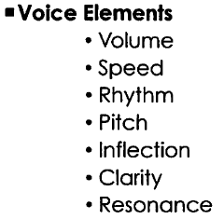
- The Power of Silence
    - Silence can be one of the most powerful tools of communication
    - The urge to fill silence is something we have to learn to recognize and use
- Silence as a communications tool
    - Silence of pauses can be a meaningful communicative act between people
    - The silence is intentionally driving behavioral acts
    - It is endowed with the ability to produce the emergence of meanings
    - It can also force dynamic messages
- Receiving is far more than “hearing”
    - Listening for content
    - Listening for intent
    - Providing Feedback
    - Verifying the accuracy of the message received
    - Asking pertinent questions
- What happens with poor listening
    - Lower employee productivity
    - Lower morale
    - Missing numerous opportunities
    - Leads to mis-diagnosis
    - Culture deterioration
    - The art of asking questions
        - To Gain information
        - To stimulate conversation
The Socratic Method of Teaching
- To gain other’s views
- To check agreement
Affirming
- To build rapport and trust
- To verify information
Types of Questions
- Closed
    - One word answers
- Open
    - Opinions
    - Thoughts
    - Feelings

- The Goals of our Questioning
  - Fact Finding
  - Feeling Finding
  - Clarifying
  - Expanding
  - Directing
- Questioning Strategies
    - Have a Plan
        - Be clear about where you want to go
    - Keep the questions simple
        - One answer at a time
    - Stay Focused
        - Hold tangent questions till later
    - Be nonthreatening
        - Build trust
    - Ask permission
        - ”Do you mind if I ask about…”
    - The power of Active Listening
      - Research
        - Ask appropriate questions
        - Provide empathy statements
      - Exercise emotional control
        - Recognize an emotional event
        - Pause, find common ground, visualize calm
      - Sense non-verbal messages
      - Structure the information heard
    - Get Feedback for clarity
        - Verbal
        - Non-verbal
        - Fact feedback
        - Feeling feedback
- Feedback – Making Sure
  - Don’t be ambiguous
    - Let me be sure that I understood what you said
    - Let’s see if I can review the key points we’ve discussed
    - I hear you saying…
    - As I understand it, your major point is…
  - Clarify, clarify, clarify
    - Did I hear you correctly?
    - Was I on target with what you meant?
    - Were those your major concerns?
    - Can you add anything to what we have said?
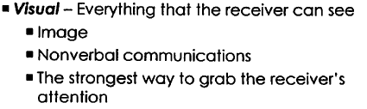
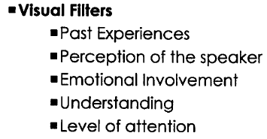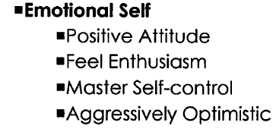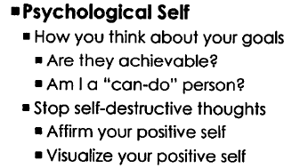
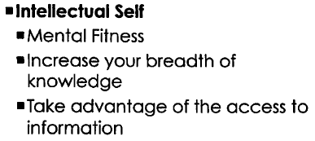
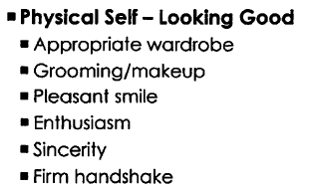
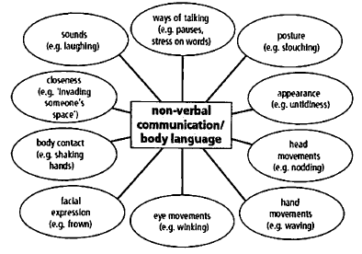
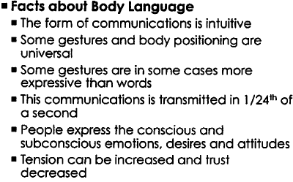
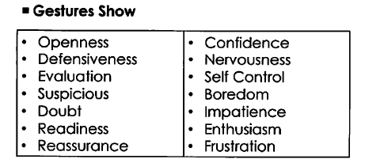
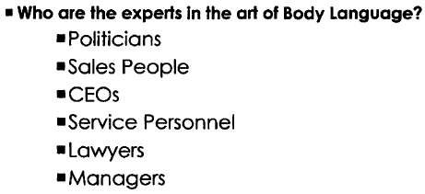
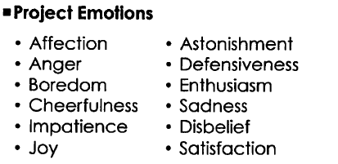
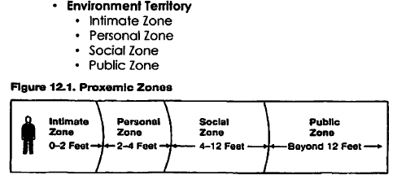
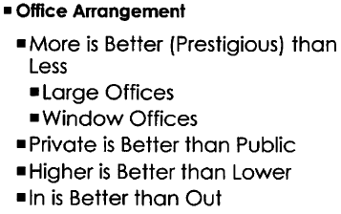
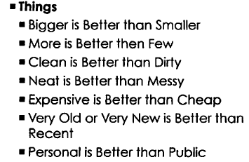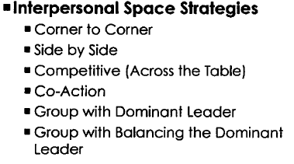
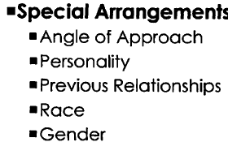

Drucker on communication
- Technology isn’t Communications – the information based company requires a willingness to ask and answer questions
- Communications is Perception – information based on how communications is received.
- Communications is 2 directional – Listening is a key skill.
- Communications and information are different – Because information is transmitted by people, there is always to potential for distortion.
- If there is not communications, there is no fun – If you can’t communicate well, you will not be able to do what you really want to do.

- Be sure when you speak that the scene is set.
- Get to meetings early to get comfortable.
- Be aware of how much you are talking
- Do not let your mind wander.
- Pay attention when listening.

Motivation
- Two Targets for Motivation and Change
  - Ourselves as the leaders
  - Our followers who follow our lead
- The Flow of Motivation and Change
  - We must be self motivated first to affect motivation in our followers.
  - We must be willing to change ourselves before we can change our team or our company

- Definition
  - Affecting those psychological forces within a person that determine:
    - The direction of behavior
“Which behaviors does the person choose?”
    - Effort level
“How hard does the person work?”
    - Persistence in the face of obstacles
“How hard does a person keep trying?”

- Self Motivation
  - Leadership Characteristics that effect self motivation
    - Their ability to channel their ego from themselves into a larger goal of building a great company
    - Their ambition is first and foremost for the institution, not themselves
    - An individual who blends extreme personal humility with intense professional will, more of a Plow Horse than a Show Horse.
    - Level 5 Leadership Hierarchy– defined by Jim Collins refers to a hierarchy of capabilities of individuals
    - Through these individuals flows personal motivation

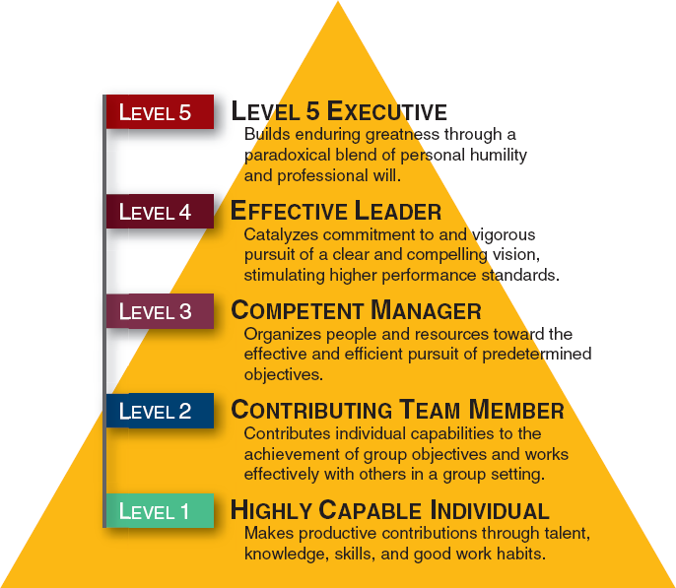

- Performance is a function of Motivation and Ability
  - Ability
    - To Carry out a set of interrelated sequences
    - To produce a result
  - Motivation
    - Psychological view – Internal Mental State
    - Managerial view – The role of the manager is to motivate employees to work harder and do better.

- Performance = f(Ability x Motivation)
  - Performance
    - An evaluation of the results of the effort
  - Motivation
    - One factor among many that contribute to level of performance
  - Performance is a function of Motivation and Ability
- Content Theories of Motivation
  - “The reasons for Motivational Behavior” - What causes it.
  - Behavioral aspects in terms of needs that “drive” behavior

- Types of Motivation
  - Intrinsic – Behavior performed for its own sake
    - Awards
    - Plaques
    - Praise
    - Internal Satisfaction
    - Career Advancement
    - Additional Training
    - Cost - 0$ (or very little $)
  - Extrinsic – Behavior performed for material or social rewards
    - Pay Raises
    - Bonuses
    - Benefits
    - Equity
    - Cost: $$$$
- Reinforce the Right Behavior
  - Don’t reinforce the wrong behavior
  - Link the reward with moving the company forward
- Reward in a Timely Manner
  - Do not postpone rewards too long
  - Offer incentives and rewards often
- Administer Rewards equitably
  - Fairness is key
  - Remember that perceptions are a person’s reality
- Provide salient rewards
  - Make the reward meaningful
  - Offer cafeteria programs
  - Create performance based credit programs
  - Vacations and Restaurant visits
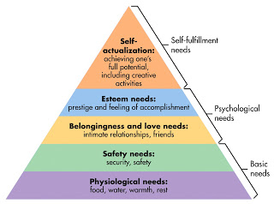
- ERG Theory
  - Existence Needs
    - Self Development and Creative needs
  - Relatedness Needs
    - Good Interpersonal Relations with Open Communications
  - Growth Needs
    - Basic needs of human survival
    - Food, Water, Clothing, Shelter and Safety
- The Job Characteristics Approach
The nature of the work itself affects motivation and performance.
  - Work Outcomes result from work activities
    - Internal Work Motivation
    - Quality of work
    - Job Satisfaction
    - Absenteeism and turnover
- Critical Psychological States of Job Theory
  - Meaningfulness of the work
  - Experienced responsibility for outcomes
  - Knowledge of results
- The Process Theories – How does Behavior Change?
  - Reinforcement Theory
    - Type of Reinforcement
      - Positive – A positive act is the result of a behavior
      - Negative – An undesirable consequence is removed
      - Punishment – Negative consequences applied
      - Extinction – Stopping a reinforcement that is maintaining a behavior
  - Reinforcement Theory
    - Schedules of Reinforcement
      - Continuous Schedule
      - Fixed Interval
      - Variable Interval
- Expectancy Theory
  - A worker will do things that he will desire based on some successful probability.
  - The strength of the desirability of the satisfaction is call a Valence – an anticipated value.
  - High positive valences are most desired.
- Goal Setting Theory
  - A worker with high goals will do better than someone with low goals.
  - Specific goals lead to higher performance
  - If a worker knows what he wants to do, he will do better than someone with vague goals.
  - Participation in goal setting is related to higher performance
  - Good feedback on goal achievement is necessary
- Goal Setting Theory
  - Not only targeted to improve individual performance
  - Also, need to further organizational goals
  - Specific Goals are Key
    - Direct attention and action toward goal-relevant activities
    - Cause employees to exert higher levels of effort
    - Cause employees to develop action plans
    - Cause employees to persist in the face of obstacles and difficulties
- Management by Objectives (MBO)
  - Three steps
    - Goal Setting – Joint agreement Manager and Executive
    - Implementation – Manager autonomously develops the plan to meet the goals
    - Periodic assessments are performed
    - Evaluation – Review results and how to improve for next round
- Equity Theory
  - Like work outputs and rewards should be equitable across the team.
  - Teams should be treated equally
  - Unfair situations should be resolved.
Historical Perspective of Motivation
- Scientific Method
- Job Enrichment
- Job Enlargement
- Job Characteristics

- Job Designs: Historical Perspective
  - Scientific Method-
    - 1911 – Frederick Taylor - Principles of Scientific Management
Job simplification
Job Specialization
Time and motion studies – Piecework approach

- Job Designs: Historical Perspective
  - Job Enlargement
    - 1940-50’s
    - More tasks being assigned to workers
    - Looking for more Intrinsic motivation
  - Job Enrichment
    - 1960’s
    - Provide for employee growth with more responsibilities
    - Employees allowed to:
Plan their work schedules
Decide how work would be performed
Check their own work
Learn new skills
  - Job Characteristics Model – 1970’s
    - Looking to reduce turnover and absenteeism
    - Looking to increase intrinsic motivation with different job characteristics
    - Core Job Dimensions
Skill variety – more skills used on the jog
Task Identity – whole pieces of work from beginning to end
Task Significance – importance from a global view
Autonomy – Freedom to schedule
Feedback – from bosses and customers

Change
The coping process of moving from a present state to a desired state in response to internal or external factors. We have to do things differently in the future.

- Organizations many times must make deep change
  - Internal and external alignment is lost.
  - The choice on direction can be:
    - Adapt
    - Take the road to slow death
  - To Adapt, the leader must be willing to take risk, moving outside the well-defined boundaries.
  - In the face of imminent danger
    - Leaders must learn new ways
    - Continually creating new and inventive solutions needed for today’s needs

- Personal Change
  - Deep organizational change can only be made when the people also commit to deep change
    - We need to journey into unknown territory and confront wicked problems we encounter
    - The objectives may not be clear
    - The path may not be paved with familiar procedures
    - We leave our comfort zone
  - The Alternative is to choose the choice of slow death
    - Accepting the status quo
    - Watching failure arrive
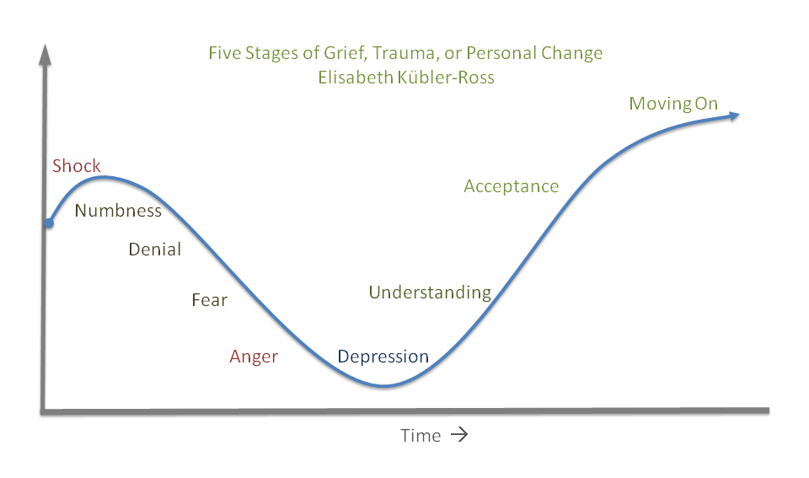

- Two Types of Organizational Change
  - Unplanned Change
    - Emergency Measures
Technology, Economic Conditions, competition, internal challenges
  - Planned Change
    - Call for improvement
Deliberate attempts at quality improvement, cost savings
  - Regardless of type
    - The change must have a long term view

- Three Phases of Planned Change
  - Unfreeze –
    - Gain acceptance the need for change
    - Usually requires some upsetting event if no adjustment is made
    - Need to point out the cost of the change is worth the gain
  - Change –
    - Rearrangements need to be made
    - Letting go of the status quo is required
    - High Anxiety
  - Re-Freezing –
    - New norms need to be cemented in place
    - Management need to reinforce the change
- Recognize the need
  - Understand the “pain”
- Diagnose and lay out the plan
  - Formulate the goals
  - Determine the Stakeholders’ needs
  - Understand the driving forces
- Managing the Transition
  - Introduce support, education, encouragement and resources
- Measure Results and Maintain Change
  - Collect feedback
  - Arrange for more training and more emotional support
- Some Common Targets for Change
  - Strategy – Vision, Mission, Strategic Plans
  - Structure – Departments, Divisions
  - People – Replace key players, new skills needed
  - Technology – New systems needed
  - Processes – New programs needed
  - Management – Need for more democratic leadership
  - Products and Services – Complaints requesting change
- Resistance to Change
  - Selective Perception – People perceive things differently
  - Lack of Information – Lack of understanding if things are not clearly presented
  - Fear of the Unknown – Uncertainty of what might happen to people’s well being
  - Habits – People prefer what they know
- Resistance to Change
  - Resentment toward the Initiator – People feel the changes are arbitrary with lack of consideration
  - Suboptimization – People will see others benefiting more
  - Structural Stability – Hierarchy could change
- Overcoming Resistance to Change
  - Education and Communication – will reduce anxiety
  - Participation and Involvement – feelings of control and ownership will arrive
  - Facilitation and Support – managers show empathy and understand anxiety
  - Negotiation and Agreement – offering compromises
- Overcoming Resistance to Change
  - Manipulation and cooptation – Selective use of influential tactics and statements
  - Coercion – Use of executive override
  - Promote positive attitudes toward change
    - Focus on opportunities and benefits
    - Dealing realistically
    - Letting go of bad situations
    - Promoting hope
- Leading Organizational Change
  - Establish a sense of Urgency
  - Form a powerful coalition – Build a team of influencers
  - Develop a compelling new vision and strategy
  - Communicate widely
  - Empower others to act on the new vision
  - Generate short term wins
  - Consolidate gains and create greater change
  - Institutionalize changes into the organizational culture

Leadership: Vision and Values by Tom Kehler
- At the core to leadership is a deep commitment to a vision and values that engender trust in customers, employees and suppliers.
  - Lead by solving problems
  - Share a vision
  - Take risk (and be accountable for the results)
  - Serve your team
  - Build trust (it is not about you)
Authentic leadership
- Authentic leaders believe their leadership emerged from their life stories
- Something in their experience makes them want to change something, to treat people in a right way
- There is a clear sense of right and wrong
- They have a burning desire to lead themselves through a journey
Key elements
- “Authentic leaders bring people together around a shared mission and values
- Create a vision in a form that everyone can share – Define reality!
- Participate and serve the needs of all stakeholders
- Empower others to lead
- Live a clear sense of shared values
- Thank and reward
Technology and leadership
- Opportunities created by discontinuities
- We are living in a unique period of frequent and numerous change
We are still at the beginning
- With each wave there are a hoard of players and one or two winners
- How do you play to be a winner?
  - Timing is critical
    - Is the infrastructure in place or do you have to create it?
    - Is it a “whole” solution to a problem?
  - Never get to far ahead of the customer
  - Sometimes a single individual leader can ride several evolutionary cycles of a discontinuity
Leading yourself
- Gaining self-awareness
- Practicing your values and principles under pressure
- Balancing your extrinsic and intrinsic motivations
- Building your support team
- Staying grounded by integrating your life
- Understanding your passions and purpose of your leadership.
Leadership in a larger company
- What are the stated and actual company values?
- Do they in some way measure their leadership in their sector?
- Do they in some way measure the leadership of their executives and managers?
- Are they committed to living the promise they make to their customers?
- Why did I omit questions on financials?
Understand your sphere of influence
- Think like a CEO BUT
  - Lead first in the area you were hired to perform
- I can’t tell you how many engineers who worked for me knew more about marketing and sales than the heads of those organizations
- Once you are performing at a high level of excellence suggest improvements for the company

