IEOR Quiz 1 Review Sheet
Entrepreneur- a person who organizes and operates business(es), taking on financial risk to do so
Intrapreneur- a manager within a company who promotes innovative product development and marketing

Entrepreneur
- Assembles and then integrates all the resources needed to found a company.
- In the face of scarcity – money, people, and time
- In the face of uncertainty with an unproven business model and strategy
- All in an effort to transform an idea or invention into a viable business

Startup  - Founder and friends  - Investor focused  - Highly fluid  - Unique product approach  - Runway concerns  - Short term goals  - High risk/burnout  - Assertive leadership | Key Organizational Behavior Skills  - Key Leadership elements and theories  - The Softer Side of Leadership  - Communications  - Decision Making  - Motivation  - Team Building  - Negotiations and Conflict  - Influence

Leadership theories
Great Man Theory  - Monarchies/Kingdoms  - Charismatic Reverence  - Hereditary Hierarchy  - Military and Government Control  - Absolute Power  Trait Theory  - Physical Characteristics  - Power and Status positions  Autocratic  - Firm control  - With a single leader  Democratic/Participative  - Concept of shared thought between leaders and followers  Laissez-Faire  - A lack of Leadership  - Organization expected to run on its own | Resonant Styles  - Positive Resonant Leadership Styles (Democratic)  - Visionary – articulation of the a shared dream  - Coaching – personal guidance  - Affiliative – harmony through connectivity  - Democratic – building consensus  - Negative Non-Resonant Leadership Styles (Autocratic)  - Pacesetter – impatience at lack of meeting standards  - Commanding – my way or the highway  - Styles change based on the situation  Contingent and Situational Theory  - No predictable optimum course of action  - Internal and External environmental forces influenced style  - Leadership styles will change based on the situation.
Transactional – Manager Focus  - Task oriented  - Controlling behaviors through corrective action  - Goal driven with measurement focus | Transformational – Leader Focus  - Vision  - Proactive approach  - Charismatic approach  - Trust  - Persistence  - Dependable
- Leaders  - Innovators  - Creators  - Developers  - Investigates reality  - Sets the culture  - Creates the vision  - Creates change  - Creates effectiveness | - Managers  - Administrators  - Maintainers  - Executors  - Accepts reality  - Maintains the culture  - Delivers on the goals  - Implements change  - Creates efficiency
Principle Centered Leadership
  - Alignment – Creation of a flat, flexible organization with a trusting culture where worker performance is internally motivated
  - Empowerment – Establishing a performance agreement, overlapping worker’s needs with the needs of the organization- based on high trust
  - Trust – The emotional bank between two people to create a win-win performance
  - Trustworthiness – Personal character and competence permeate the organization

The Spirituality of Leadership
  - Emotional Intelligence
  - Culture
  - Ethics
  - Values
  - Stewardship
  - Change Agency

Self-Awareness - Recognize and understand moods, emotions  - Emotions  - Assessment  - Confidence | Social Awareness - Understanding emotions and makeup in others  - Empathy  - Organizational awareness  - Service orientation
Self-Management - Ability to control or redirect impulses and moods  - Control  - Trustworthiness  - Conscientiousness  - Initiative  - Motivation | Social Skill - Ability to manage relationships  - Vision  - Influence  - Communications  - Conflict management  - Teamwork

Four elements of culture
- Artifacts – Stories and myths (the Ah-Ha moment)
- Espoused values – Preached and practiced
- Share assumptions – Vision, strategic intent, core strategies (What would Carl do?)
- Established by the leader of the organization

Ethics- the standards of right and wrong that influence behavior

Stewardship- willingness to be accountable for the wellbeing of others by operating with service, not just control.
Servant leadership- transcends self-interest to serve the needs of others by helping them grow professionally and emotionally.

- What the Leader Stands for:
  - Honesty
  - Transparency
  - Authenticity

- Change – A Constant Element of Leadership
  - Values Based Leadership – making the right choices
  - Leaders fail (to create change) when they have an inappropriate attitude and philosophy about the relationship between themselves and their followers.
  - Values of Effective Change Agents
    - Integrity
    - Trust
    - Listening
    - Respect for followers

- Communications is 2 way
  - Responsibilities of the Communicator
    - Clear Messages
    - Understood Message
    - Verbal and Non Verbal Messages
    - The Power of Silence
  - Responsibilities of the Listener
    - Active Listening
    - Being Present and engaged

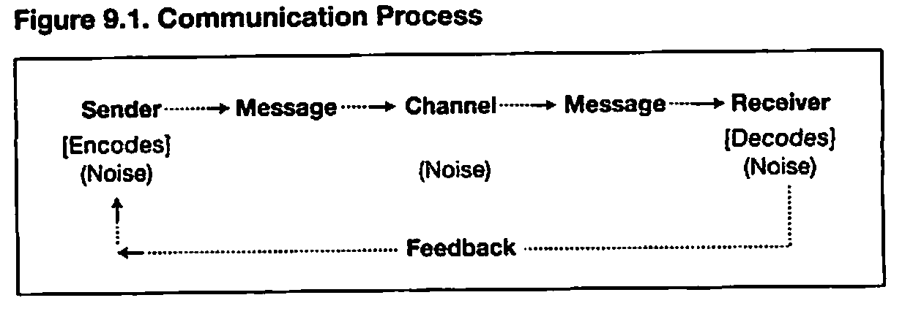 | - Sending - Information  - Encoding in a format that will get an idea across  - Hearing – Information  - Decoding the message  - Must be received  - Must be understood  - Noise must be avoided

- Tool to improve communications
    - Feedback
    - Helps to determine how clearly a message is heard

- Receiving is far more than “hearing”
    - Listening for content
    - Listening for intent
    - Providing Feedback
    - Verifying the accuracy of the message received
    - Asking pertinent questions
    - The power of active listening
Concentrate
        - Provide full attention
        - Remove all noise
Acknowledge
        - Make eye contact
        - Participate with verbal responses
The Intersection – Entrepreneurship and Leadership
  - Transformational Leadership
    - The movement from managing to becoming a visionary and culture architect
  - From the Idea to the Team
    - From the solo idea to the group responsibility
  - Interrelationships – the people connection
    - Paying attention to the people – building trust
  - Crossover from IQ to EI
    - Re-focus from the technical to the personal
  - Surrounding yourself with motivated people

Groups – Folks that meet regularly and have some distinction, strive for independent objectives.
Teams – Are groups that are much more sophisticated
  - Complementary skills
  - Common company goals
  - In some cases, share management
  - Are accountable together.
- Effective Teams Will
  - Target effective and meaningful team projects
  - Select team members that bring high performance
  - Make choices and tradeoffs wisely, maximize the value of time and money and get high performance from each team member
  - Never leave performance to instinct and chance

Types of company to build
“Lifestyle”  - The majority of businesses in the world  - Self-controlled  - Bank/FFF funded  - Modest growth aims | “Classic Startup”  - Shoot for the moon  - Angel/VC funded  - Board controlled  - BIG growth goals
10 traits of entrepreneurs  - Persistence  - Confidence  - Vision  - Action  - Dedication  - Faith  - Integrity  - Adaptability  - Courage  - Communication | 10 myth of entrepreneurs  - Born, not made  - Well educated, rich and young  - Big gamblers  - Loners and cannot work with others  - Only care about money  - Break-through invention or technology  - Fail and you will never get a second chance  - Couldn’t get a good job so they work for themselves  - Take huge risks to succeed  - You will have no “life”
7 steps to entrepreneur
- Find/fill unmet customer need
- Plan for profitability
- Strive for sustainability
- Establish credibility
- Gather resources
- Lead/manage effectively
- Maintain life balance

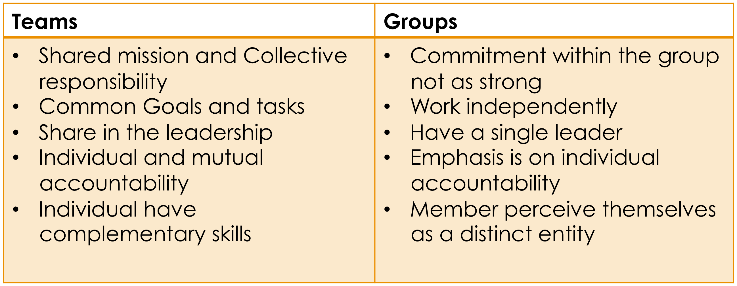
- Structures of Groups and Teams
  - Formal
    - Command Group – Usually described as Departments
    - Task Force – A collection of people focusing on a specific goal
  - Informal
    - Friendship Group – People who enjoy each other’s company
    - Interest Group – People with a common goal or objective related to their membership

Types of Teams
Functional Teams  - Line Manager  - Subordinates  Cross-Functional Teams  - Members from different departments  - Leader serves as a consultant  Self-Managed Teams  - Given authority to manage decisions to meet goals  Virtual Teams  - Foreign locations | Virtual Teams  Advantages:  - Wide reach of time and distance  - Diversity could expand expertise  - Reduces costs  - Improves team communications  Disadvantages:  - Lack of physical interaction  - Lack of verbal and non-verbal communication
- Signs of Team Maturity:
  - Feelings are accepted without judgment
  - Healthy disagreements occur over real and important issues
  - Team decisions are made in the face of dissent which is encouraged
  - Members of a team understand the nature of their involvement

- Stages of Team Development
  - Forming – Orientation
    - Getting to know each other
    - Establishing a common understanding
  - Storming – Conflict
    - Members resist being controlled
    - Disagreements arise
  - Norming – Cohesion
    - Members develop feelings of friendship and camaraderie
    - A common purpose is shared
  - Performing – Effective Structure
    - Members work toward achieving common goals

Team Size  Advantages of Smaller Teams  - More Frequent Interactions  - Information more easily shared  - Members get to know each other and recognize contributions  - Motivation exists toward team goals  - Members are more satisfied. | Advantages of Larger Teams  - Member’s skills  - Abilities  - Knowledge  - Experience  - Greater separation of tasks, better focus  - More skills from better focus
- Team Composition
  - Advantages of Homogeneous Members
    - Members tend to get along with each other
    - Information is shared and not horded
    - Low tendencies toward conflict
  - Advantages of Heterogeneous Members
    - Diversity creates different views and potentially better decisions
    - Team performs at a high level with more variety of resources available

- Team Efficiency
  - Shared belief sets the stage to achieve goals
    - Composition of the team
    - Knowledge of the team
    - Skill levels of the team
    - Willingness to work together
    - Willingness to share information
    - Use of shared resources

- Social Facilitation
  - Experienced team members performance is strong
    - Based on well learned behaviors
    - Wisdom from earlier activity
  - Difficult situations may require some isolation for members to allow them to focus

- Roles – a set of behaviors that a member is expected to perform by virtue of holding this role
  - Establishing tasks
  - Responsibilities – task related
  - Rights – resources related

- Roles actions
  - Tells members what they should be doing
  - Defines standards of evaluation of behavior
  - Determines how to reward members
- Rules – Standard Operating Procedures
  - Day to day requirements
  - Task descriptions

- Advantages of clear rules
  - Define proper engagement
  - Define control of behavior
  - Facilitate evaluations
  - Helps training new employees

- Team Norms – informal rules of conduct
  - Conformity of the norm
    - Compliance – assenting and following the norm
    - Identification – with others who comply
    - Internalization – Believing in the norm
  - Deviance from the norm
- Team Cohesiveness
  - Cohesive teams have high level of interaction
    - Similar interests
    - Common goals
    - Personal attractiveness
  - Will create Power and Influence
  - High influence can create
    - Groupthink;
- Team Cohesiveness Factors
  - Conditions leading to team formation
  - Team success
  - External Threat
  - Fair Rewards Allocation

- Cooperation
  - Cooperation means giving support
  - Contributing time and energy
- Competition
  - When individualism overrides team effort
  - Can be positive when driving to better performance
- Creating a good Culture
  - Instillation of value of teams to organizational success
  - Respect skills of new team members
  - Insert team building training
  - Develop effective reward structures
  - Provide fair and clear goals
  - Provide avenues for success
  - Empower teams, minimize micro-management

- Team Learning
  - Team of specialists
  - Performance depended on each other
  - Team is in alignment, a commonality of direction
  - There is a resonance in the team
  - Key critical dimensions:
    - There is the need to think insightfully about complex issues
    - There is a need for innovative, coordinated action
    - There are roles for team members from other teams
- Team Learning
  - Dialog is key
    - All participants must “suspend their assumptions
    - All participants must regard one another as colleagues
    - There must be a strong facilitator who holds the context of the dialog
  - In a dialog, different views are presented toward discover
  - In a discussion, decisions are made.

- Perception
  - Creating an internal picture of the external world.
- Judgment Biases
  - Opinion expressed as facts, typically called wisdom or,
  - Discernment which is the activity of determining the value and quality of something by going passed mere perception and making a judgment about it.
- Attribution – Finding causes of behavior
  - Concept in psychology whereby people attribute traits and causes to things they observe.
- Why are Perceptions important?
  - Motivation and Performance
  - Fairness and Equity
    - Especially in the global work force
  - Ethical repercussions
- The Components of Perception
  - The Perceiver – the person trying to interpret
    - Observations
    - Input from senses
  - The Target – whatever the perceiver is trying to make sense of
    - Persons, Groups of persons
    - Events or situations
    - Ideas
  - The Situation – context where perception takes place
    - Meetings, coffee machines, hallways, etc.
- Characteristics of the Perceiver
  - Knowledge – Schemas
    - Experiences
    - Storage of sensory information in memory
    - Interpretation of reality in alignment with expectations
  - Needs and Desires – Motivational State
    - The actual time of perception
  - Feelings – Moods
    - Feelings at the time
    - Might “wait” until a mood changes
- Characteristics of the Target of the Perception can influence Perception
  - Ambiguity – lack of clarity in the mind of the perceiver
  - Social Status of the Target
    - High status can be misleading
  - Impression Management by the Target
    - Behavior matching
    - Self promotion
    - Conforming to situational norms
    - Flattering
    - Agreement with the perceiver
- Judgment Biases – tendency to interpret data that can result in inaccurate perceptions
  - Problems arise from conclusion or judgments that
    - Distort of misrepresent facts
    - Disagree with the perception of others
  - Relationship biases
    - Performance evaluations
    - Selection interviewing
    - Group meetings
    - Customer relations
- Sources of Judgment Bias
  - First Impressions
  - Halo Effect
  - Projection – Similar to me
  - Implicit Personality Theory
  - Stereotyping
- Halo Effect
  - One or a few personal characteristics effect evaluations of other characteristics
    - Trait Characteristics
One characteristic, ie, how one dresses, will bias an overall view of potential future action or performance.
    - Self Image Equating
We have a positive bias for attributes that we might have.

- Projection – Similar to me
  - Psychological mechanism of attributing our own traits to others
  - If others do not project our personal traits, we create
    - False Impressions
    - Misperceptions are likely to follow
- Implicit Personality theory
  - Linking characteristics improperly
    - Honest people = Hard working people
    - Quiet people = Are devious
    - Sloppy Dressers = Unorganized workers
- Stereotyping
  - Linking group characteristics to individuals
  - Fed by prejudice and myths
  - Perpetuated by these myths
  - What groups are stereotyped?
    - Ethnic groups, age groups, political groups, sexual orientation
- Attribution Theory – Judging Other People’s Behavior
  - Fundamental Attribution Error - When we judge others – We tend to attribute causes of behavior
  - Factors that affect attribution:
    - Consistency – “once late – expected to be late”
    - Distinctiveness – “if being late in uncommon – must be an extenuating reason”
    - Consensus – “if someone doesn’t follow the norm – behavior is internally motivated”
    - Privacy – “action in private – judged to be internally motivated
    - Status – “higher the status – the more responsible”
- Attributions
  - Internal – characteristic of the person
    - Abilities
    - Personality
    - Motivation
  - External – factors external to the person
    - Task difficulty
    - Luck
- Attribution of our Own Behavior
  - Self Serving Bias
    - Believe we generally don’t make mistakes
    - Failure attributed to
      - Bad luck
      - Unfair conditions
      - Impossible odds
Readings

Cult
- Strong team, strong beliefs in common
- Culture is dynamic
- High quality team
- High trust

A-player
- Best, all-around player
- Strong network
- Constant attitude
- Inspirational
- Contribute positively
- Skeptical, questioning

The candor effect
- Candor gets more people in the conversation, and when you get more people in the conversation, to state the obvious, you get idea rich.
- Candor generates speed. When ideas are in everyone’s face, they can be debated rapidly, expanded and enhanced, and acted upon.
- Candor cuts costs- lots.

