EE 40 Notes
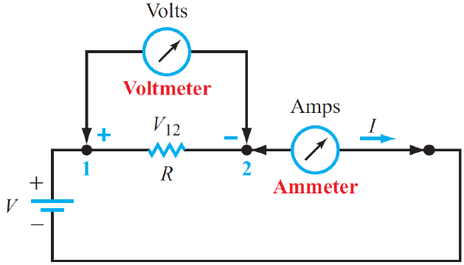 | Voltmeter: measures voltage without drawing current  Ammeter: measures current without dropping voltage  Open circuit, no path for current flow R = infinity  Short circuit, no voltage drop R = 0
Kirchhoff’s current law (KCL)  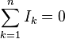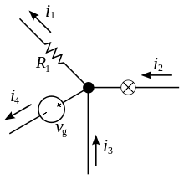  i₂ + i₃ = i₁ + i₄ | Kirchhoff’s voltage law (KVL)  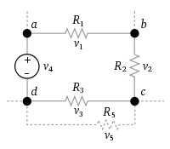  v₁ + v₂ + v₃ - v₄ = 0  add up voltages in a systematic clockwise movement  assign a positive sign to the voltage across an element if the (+) side

i > 0 as entering the + side p>0 power delivered to device
i < 0 as entering the – side p<0 power supplied by device

Branch: single element, such as a resistor or source
Node: connection point between two or more branches
Extraordinary node: connection point between at least 3 branches
Loop: closed path in a circuit
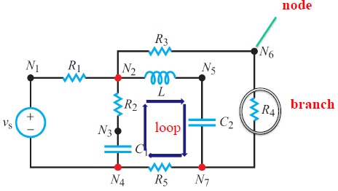
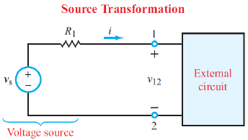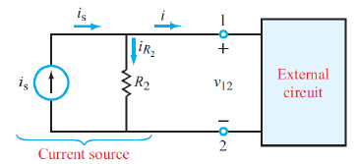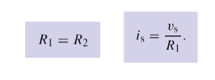

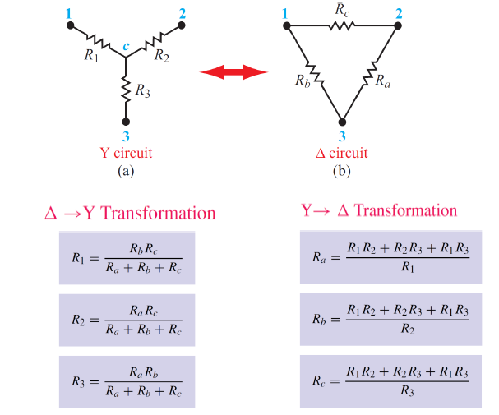
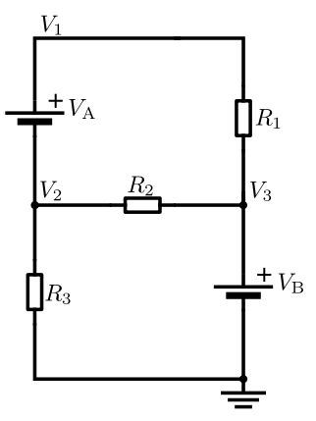 | By viewing a voltage source on a wire as a point source voltage in relation to other point voltages located at various nodes in the circuit, relative to a ground node assigned a zero or negative charge, both V_{A} and V_{B} are super-nodes. V_{A} has two unreferenced nodes, whereas V_{B} has one referenced node (ground) and one unreferenced node.  1.5 = v_{a}/ 6 + 3.5 + v_{b}/3  v_{b} – v_{a} = 12

Nodal analysis
- Node voltages (voltages between each node and ground reference) are UNKNOWNS
- KCL equations at each UNKNOWN node constrain solutions (N KCL solutions for N Node Voltages)

Mesh analysis
Step 1
Identify all meshes, and assign each an unknown current. For convenience, use clockwise current

Step 2
Set up KVLs for each mesh

Step 3
Solve the resulting simultaneous equations

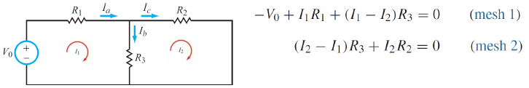
A supermesh results when two meshes have a current source (with or without a series resistor) in common.
Voltage across current source is unknown
Write KVL equation for closed loop that ignores branch with current source
Write KCL equation for branch with current source (auxiliary equation).

Summary of mesh analysis
- Mesh currents flowing in each mesh loop are UNKNOWNS
- KVL equations for each mesh loop constrain solutions (M KVL solutions for M mesh loops)

Supermesh
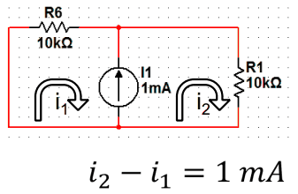a current source in between 2 loops
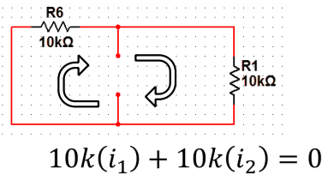write mesh equations as if circuit is like this

Inspection - Nodal  All sources are independent current sources.  Set up a matrix for all the nodes, as follows:  [ G₁₁ G₁₂ … G_{1n}] [ v1 = [i₁  G₂₁ G₂₂ … G_{2n} v2 i₂  . . .  . . .  . . .  G_{n1} G_{n2} … G_{nn} vn ] i_{n}]  Where G_{kk} = sum of all conductances connected to the node k. Conductance = 1 / resistance  G_{kl} = G_{lk} = negative of conductances connecting nodes k and l, with k ≠ l  I_{k} = total of current sources entering node k (a negative sign applies to a current source leaving) | Inspection – Mesh  [ R₁₁ R₁₂ … R_{1n}] [ i1 = [v₁  R₂₁ R₂₂ … R_{2n} i2 v₂  . . .  . . .  . . .  R_{n1} R_{n2} … R_{nn} in ] v_{n}]  Where R_{kk} = sum of all resistances in mesh k  R_{kl} = R_{lk} = negative of the sum of all series shared between k and l (with k ≠ l)  I_{k} = current of mesh k  v_{ik} = total of all independent voltage sources in mesh k, with positive assigned to a voltage rise when moving around the mesh in a clockwise direction

Step 1: Set all independent sources to 0 (by replacing voltage sources with short circuits and current sources with open circuits), except for source 1
Step 2: Apply the analysis technique of your choice to solve for the response v1 due to source 1
Step 3: Repeat for sources 2 through n, calculating in each case the response due to that one source acting along
Step 4: Sum to determine the total response v

Thevenin equivalent Norton equivalent
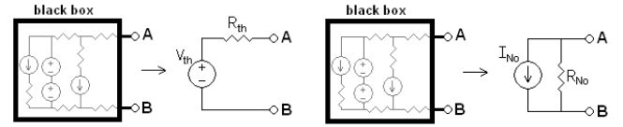

To find V_{th}, open (a) and (b) for the voltage between (a) and (b) without changing the circuit.
To find I_{NO}, short (a) and (b) and solve for the current flowing from (a) to (b) without changing the circuit.

If there are dependent sources, attach an imaginary source V_{ab} between nodes (a) and (b), find the current I_{ab}, going through this source in terms of Vab.
R_{eq} = V_{ab} / I_{ab}

R_{TH} = R_{No}
The effective resistance for either equivalent circuit is equal to the resistance between (a) and (b) with:
◦ Independent current sources open
◦ Independent voltage sources shorted

