Chemistry 112A First Midterm Review Sheet
Nomenclature for alkanes
- identify and name longest chain
- name groups attached to the longest chain
- number C’s of longest chain beginning with end closest to substituent
- arrange substituents in alphabetical order
Branching decreases the stacking of alkanes, thus lowering the boiling point. Symmetry contributes to stacking.

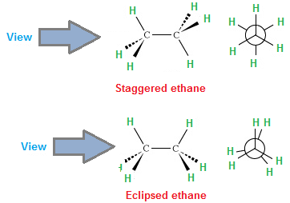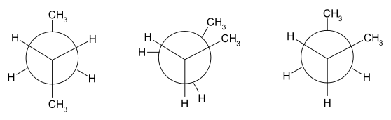
anti gauche
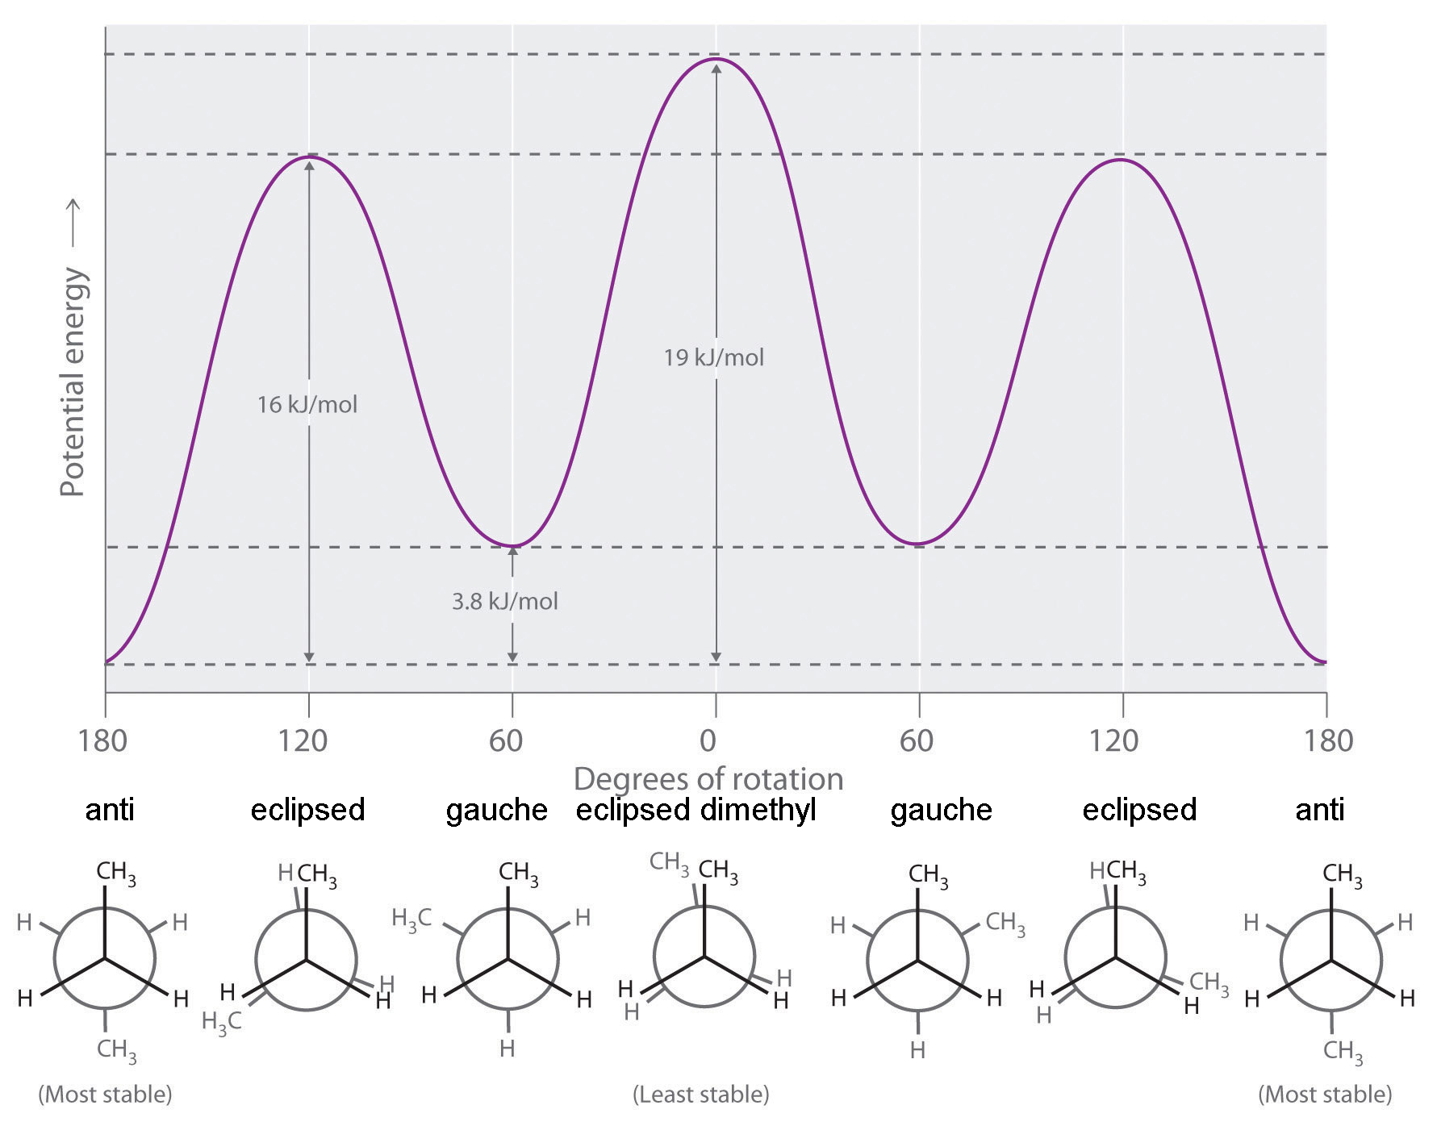
Bronsted acid- donate proton Bronsted base- give up proton
Lewis acid- accept electron pair Lewis base- donate electron pair

pKa values
<0 | ~5 | ~10 | ~15 | ~35 | ~50
HCl, HBr, HI, H₂SO₄, H₃O⁺, CH₃OH₂⁺, RH₂O⁺, RCOH⁺R | CH₃COOH | RNH₃⁺  Phenol | CH₃OH  H₂O | R₂NH | RH
General rules for the stability of anions
Stability of anions increases, pKa of the conjugate acid decreases (more acidic)
- Across the row (electronegativity)
- Down a column (increased size and polarizability)
- With less negative charge on the same atom
- With increasing resonance

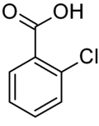more acidic than 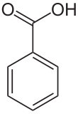because Cl is more electron withdrawing and stabilizes the anion
A molecule or ion that donates a pair of electrons to form a new covalent bond is called a nucleophile. A nucleophile is the same thing as a Lewis base. | 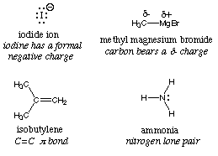
A molecule or ion that accepts a pair of electrons to make a new covalent bond is called an. An electrophile is the same thing as a Lewis acid. Any molecule, ion or atom that is electron deficient in some way can behave as an electrophile. | 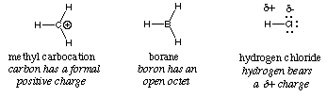
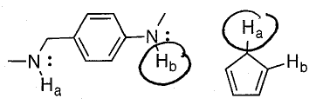
the circled hydrogen atoms are more acidic because the anions are stabilized by resonance.
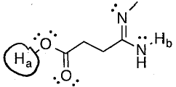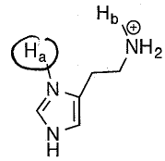
O is more electronegative than N sp2 hybridized NH is more acidic than sp3 hybridized NH

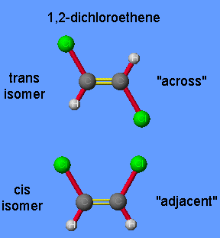 Alkene’s double bond is not rotatable. Sigma bond is stronger than pi bond.

E/Z nomenclature and CIP priority
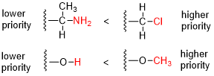 | E = entgegan ("trans") low and high on the same side.  H L  L H  Z = zusamen ("cis") high on one side, low on the other.  H H  L L  Atoms with higher atomic number have higher priority  Work outwards until the first point of difference

Double bonds counted as 2 carbons, triple as 3

Carbonyl C=O counted as C-O-C

General trend of alkene stability
More substituted more stable than less substituted (hyperconjugation- the interaction of pi orbital and adjacent C-H or C-C bonding)
Trans more stable than cis (cis is destabilized by torsional strain)

Heat of formation more negative, more stable
Heat of combustion more negative, less stable

Acid/base properties
The stronger the bond, the more acidic it is. Bond strength: C₂H₆ < C₂H₄ < C₂H₂ Acidity: C₂H₆ < C₂H₄ < C₂H₂

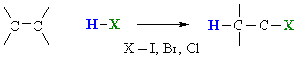 addition of hydrogen halide

Markovnikov’s rule
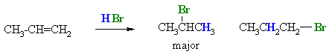
Hydride shift / Carbocation rearrangement
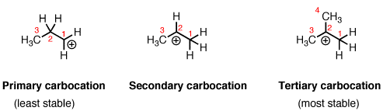

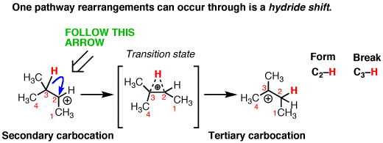
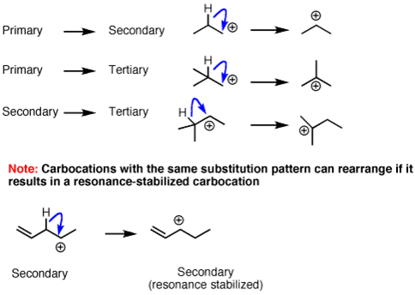

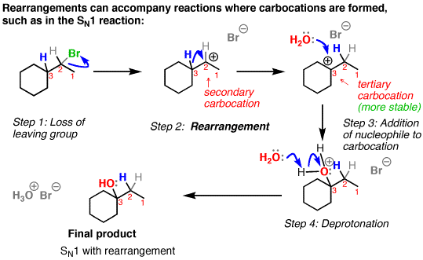
Alkyl shift
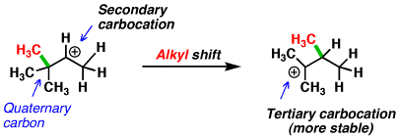
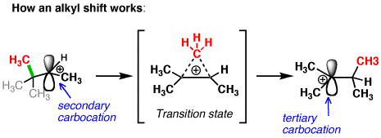
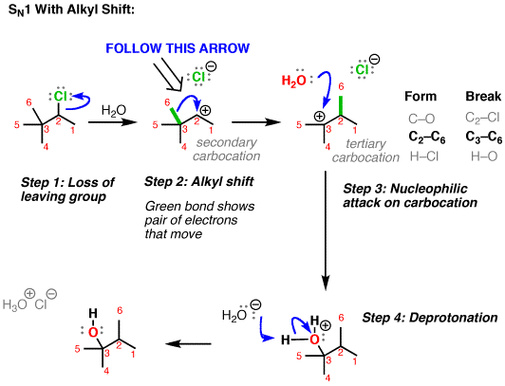

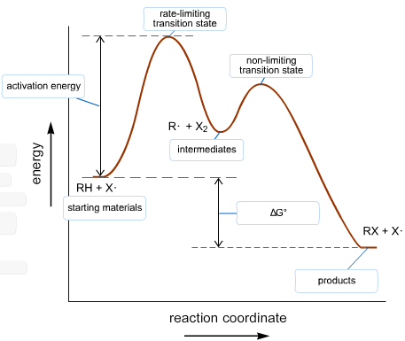 | 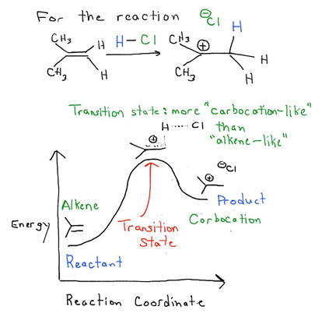
The higher hump is the rate-limiting transition state  Every 1.36 kcal/mol change in delta G is a 10 fold change in k (or rate).  The lower delta G is, the faster the reaction is. | Hammond’s postulate  The structure of a transition state resembles that of the species nearest to it in free energy. The transition state of an endothermic reaction resembles the products, while that of an exothermic reaction resembles the reactants

Hydration: the addition of water onto an alkene to form an alcohol
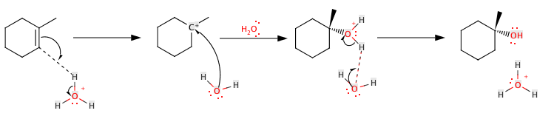
Catalyzed by a strong acid such as H₂SO₄ dP/dt = k [alkene] [ H₃O⁺]

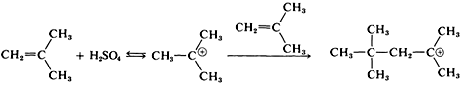 polymerization
Alkene (pi bonding orbital) is Lewis base. Carbocation (empty p orbital) is Lewis acid.

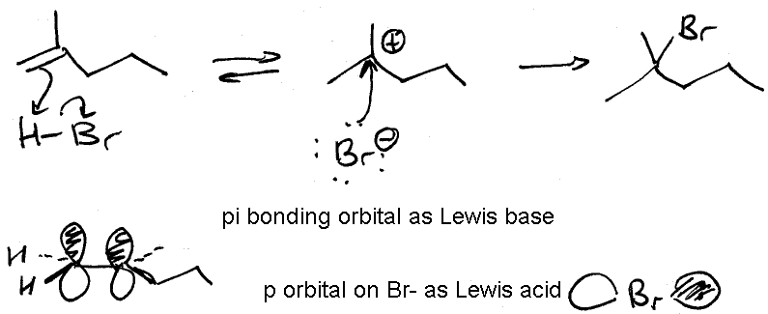
Hydrogenation: the addition of hydrogen onto an alkene to saturate a double bond
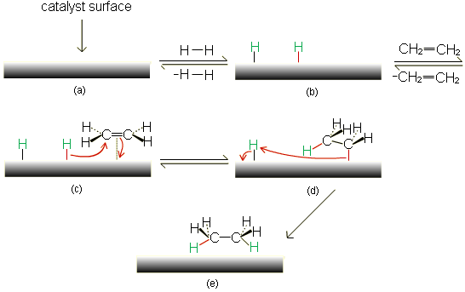mechanism

Alkene reactivity: mono > di > tri > tetra substituted

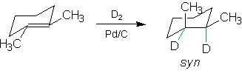 syn means that two are on the same side

