Chemical Engineering 162 First Midterm Review
Formulating a control strategy
Control objectives
Manipulated input- one that can be adjusted by the control system
Disturbance input- one that affects the process outputs but that cannot be adjusted by the control system
Output- measured or unmeasured
Constraints- soft or hard
Operating characteristics- continuous, batch, semicontinuous/semibatch
Safety, environmental, and economic considerations
Control structure

Positive gain- an increase in a process input leads to an increase in the process output
Negative gain- an increase in a process input leads to a decrease in the process output

Fail-closed / air-to-open- if signal is lost, valve will close
Fail-open / air-to-close- if signal is lost, valve will open

Feedforward- measures disturbance variable and sends this value to a controller, which adjusts the manipulated variable
Feedback- measures the output variable, compares the value to the desired output value, and uses this information to adjust the manipulated variable
Setpoint- desired value of the measured process output

Mass balances
$$\frac{dV}{dt}=F_{1}-F_{2} \frac{dh}{dt}=\frac{F_{1}-F_{2}}{A}$$
$$\frac{dM}{dt}=\dot{m_{in}}-\dot{m_{out}}$$
$$\frac{dn}{dt}=q_{i}-q=\frac{V}{RT}\frac{dP}{dt} \frac{dP}{dt}=\frac{RT}{V}\left(q_{i}-q\right) q=β(P-P_{h})$$
$$\dot{x}=f\left(x,u,p\right) \dot{y}=g\left(x,u,p\right)$$
x is the vector of state variables, u is the vector of input variables, p is the vector of parameters, y is the vector of output

Energy balances
$$\frac{dT}{dt}=\frac{F_{i}}{V}\left(T_{i}-T\right)+\frac{Q}{VρC_{P}}$$
$$u=Q-Q_{s} y=T-T_{s}$$
$$τ_{p}\frac{dy}{dt}=-y+k_{p}u$$
$$\frac{dx}{dt}=f\left(x\right) f\left(x\right)=f\left(x_{s}\right)+{\left.\frac{∂f}{∂x}\left(x-x_{s}\right)\right|}_{x_{s}}$$
$$f\left(x,u\right)=f\left(x_{s},u_{s}\right)+{\left.\frac{∂f}{∂x}\left(x-x_{s}\right)\right|}_{x_{s}}+{\left.\frac{∂f}{∂u}\left(u-u_{s}\right)\right|}_{u_{s}}$$
$${\dot{x}}^{'}=Ax^{'}+Bu^{'}$$
$${\dot{y}}^{'}=Cx^{'}+Du^{'}$$
$$A_{ij}=\frac{∂f_{i}}{∂x_{j}} B_{ij}=\frac{∂f_{i}}{∂u_{j}} C_{ij}=\frac{∂g_{i}}{∂x_{j}} D_{ij}=\frac{∂g_{i}}{∂u_{j}}$$
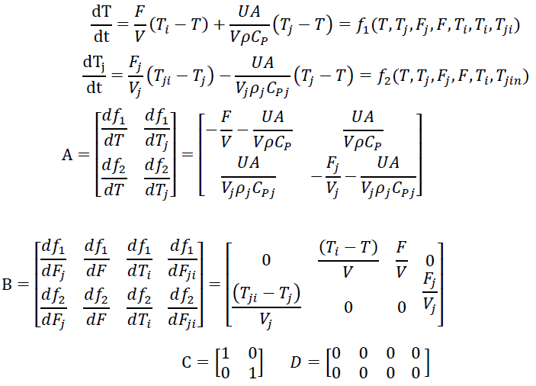
Eigenvalue
$$\det\left(λI-A\right)=0 λ=\frac{a_{11}+a_{22}±\sqrt{{\left(a_{11}+a_{22}\right)}^{2}-4\left(a_{11}a_{22}-a_{12}a_{21}\right)}}{2}$$

Laplace Transform
$$L\left[f\left(t\right)\right]=F\left(s\right)=\int_{0}^{∞}{f\left(t\right)e^{-st}dt}$$
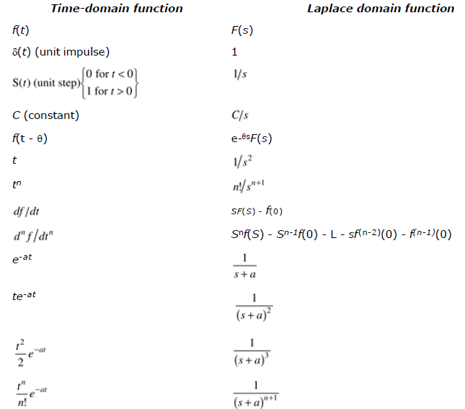
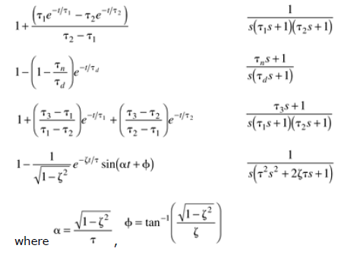
$$final value theorem: \lim_{t→∞}{f\left(t\right)}=\lim_{s→0}\left[sF\left(s\right)\right]$$
$$initial value theorem: \lim_{t→0}{f\left(t\right)}=\lim_{s→∞}\left[sF\left(s\right)\right]$$
$$\frac{d^{n}y}{dt^{n}}+a_{n-1}\frac{d^{n-1}y}{dt^{n-1}}+…+a_{0}y=b_{n-1}\frac{d^{n-1}u}{dt^{n-1}}+…+b_{0}u$$
$$L\left[\frac{d^{n}y}{dt^{n}}\right]=s^{n}Y\left(s\right)$$
$$Y\left(s\right)=\frac{N\left(s\right)}{D\left(s\right)}=\frac{C_{1}}{s-a}+\frac{C_{2}}{s-b}+… y\left(t\right)=C_{1}e^{-at}+C_{2}e^{-bt}+…$$
$$Y\left(s\right)=\frac{C_{1}}{s-a}+\frac{C_{2}}{{\left(s-a\right)}^{2}}+… y\left(t\right)=C_{1}e^{-at}+C_{2}te^{-at}+\frac{C_{3}}{2}t^{2}e^{-at}…$$

Transfer functions
$$Y\left(s\right)=g\left(s\right)U\left(s\right) g\left(s\right)=\frac{Y\left(s\right)}{U\left(s\right)}$$
The roots of numerator are zeroes.
The roots of denominator are poles.

